Moscow
Additional programs of Russian as a foreign language
https://education-in-russia.com/education-in-russia/programs?typeFilter=additional
Start date | Duration (mth.) | City | University | Program name | Program name in Russian | Screenshot
01.09.2023  (hybrid format) | 5 | Moscow | Moscow State University of Education | Russian as a foreign language and Russian culture | Русский язык как иностранный и русская культура | https://education-in-russia.com/education-in-russia/programs/123340  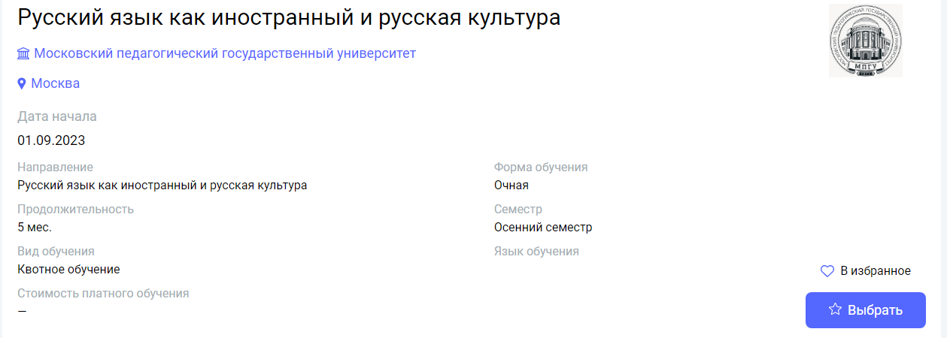
01.09.2023  (hybrid format) | 10 | Moscow | Moscow State University of Education | Russian as a foreign language | Русский язык как иностранный | https://education-in-russia.com/education-in-russia/programs/123341  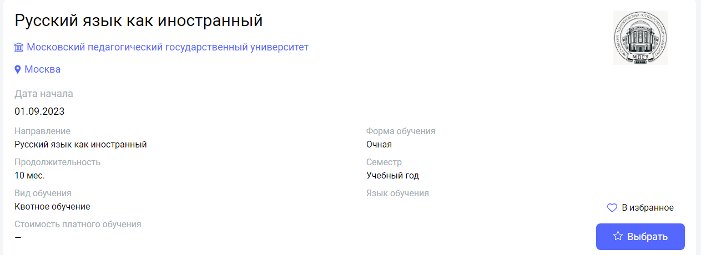
01.09.2023  (hybrid format) | 10 | Moscow | Moscow State University of Education | Russian as a foreign language and Russian culture | Русский язык как иностранный и русская культура | https://education-in-russia.com/education-in-russia/programs/123339  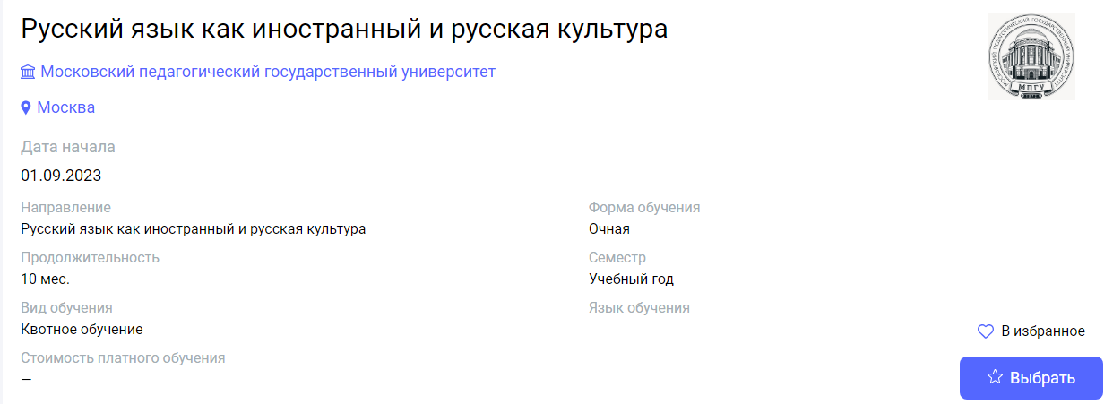
01.07.2024  (hybrid format) | 2 | Moscow | Moscow State Linguistic University | Russian as a Foreign Language. | Русский язык как иностранный. | https://education-in-russia.com/education-in-russia/programs/123338  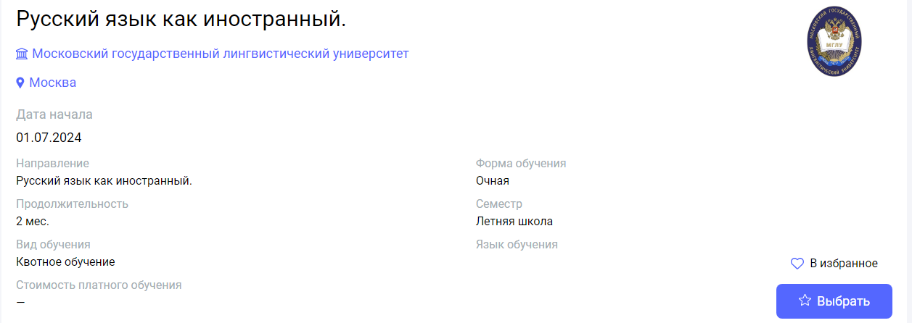
01.07.2024  (hybrid format) | 2 | Moscow | Moscow State Linguistic University | Russian as a Foreign Language. Advanced Level. | Русский язык как иностранный. Продвинутый уровень. | https://education-in-russia.com/education-in-russia/programs/123334  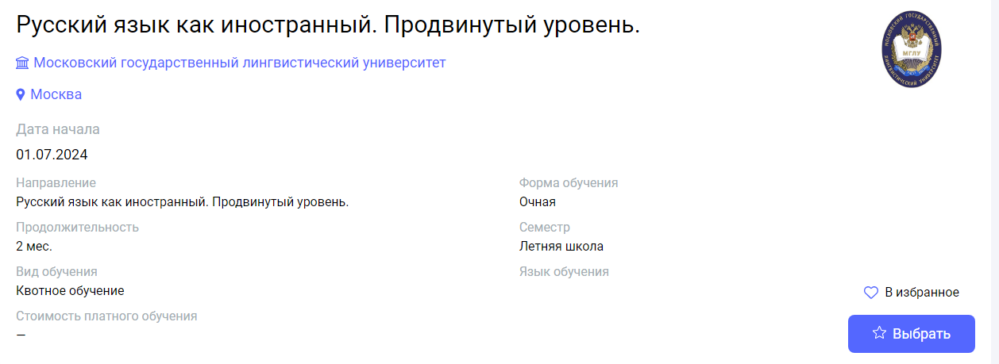
01.07.2024  (in-person) | 1 | Moscow | Pushkin State Russian Language Institute | Summer School. Practical Course of Russian as a Foreign Language (July) | Летняя школа. Практический курс русского языка как иностранного (Июль) | https://education-in-russia.com/education-in-russia/programs/123446  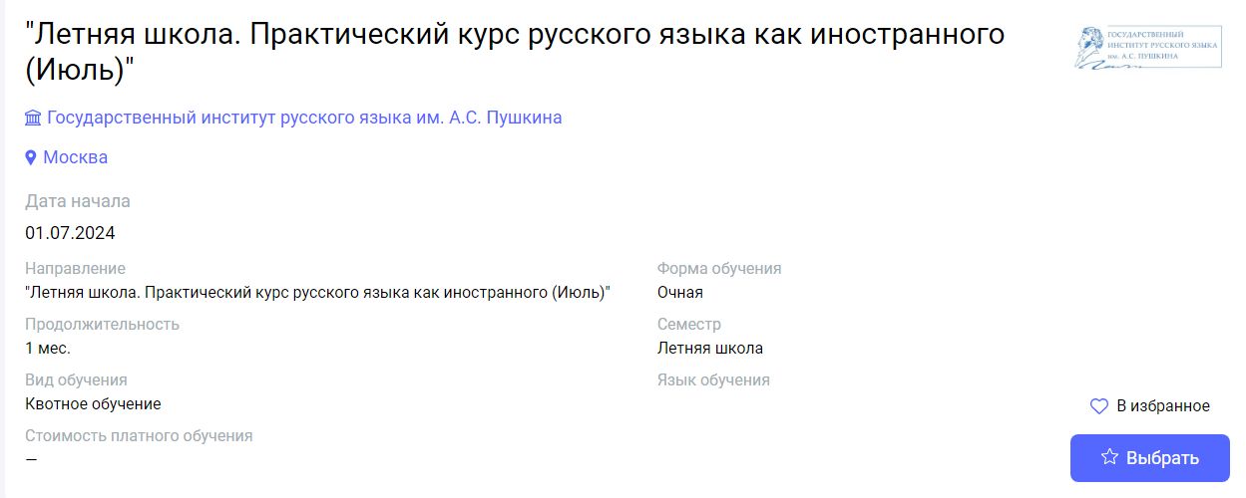
01.07.2024  (in-person) | 2 | Moscow | Pushkin State Russian Language Institute | "Summer School. Practical Course of Russian as a Foreign Language (July-August)" | "Летняя школа. Практический курс русского языка как иностранного (Июль-Август)" | https://education-in-russia.com/education-in-russia/programs/123445  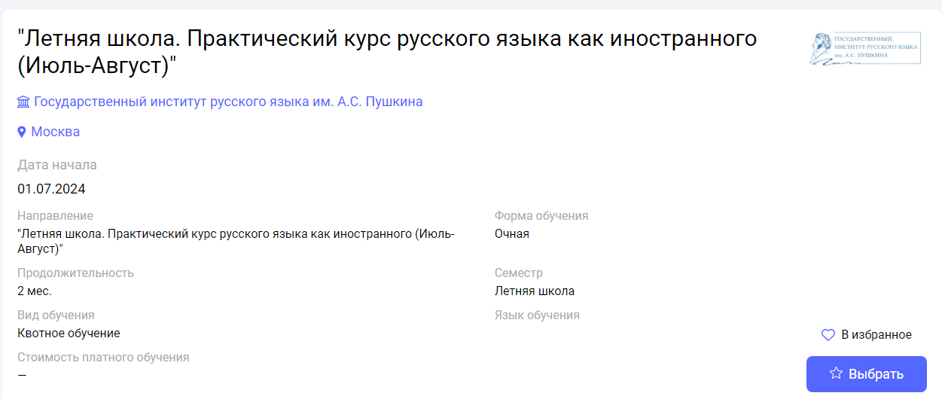
01.07.2024  (hybrid format) | 2 | Moscow | Moscow State Linguistic University | Russian as a Foreign Language. Advanced Level. | Русский язык как иностранный. Продвинутый уровень. | https://education-in-russia.com/education-in-russia/programs/123334
29.07.2024  (in-person) | 1 | Moscow | Pushkin State Russian Language Institute | Summer School. Practical Course of Russian as a Foreign Language (August) | Летняя школа. Практический курс русского языка как иностранного (Август) | https://education-in-russia.com/education-in-russia/programs/123433  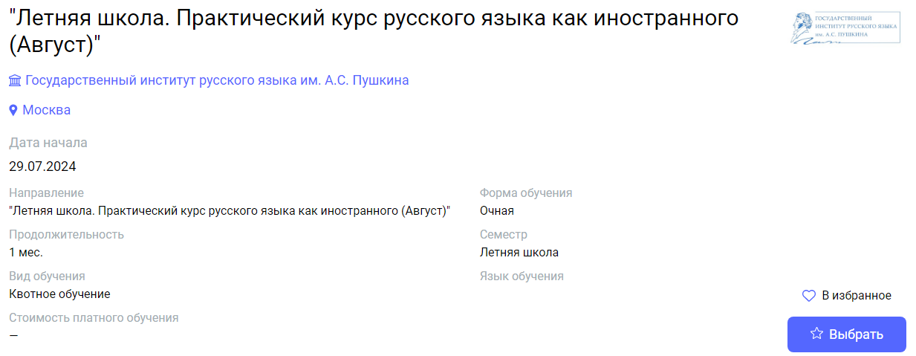
26.08.2024  (in-person) | 1 | Moscow | Pushkin State  Russian Language  Institute | "Practical Course of Russian as a Foreign Language for Students of Philological Faculties" (for Japanese university students) | "Практический курс русского языка как иностранного для студентов филологического профиля" (для студентов ВУЗов Японии) | https://education-in-russia.com/education-in-russia/programs/123434  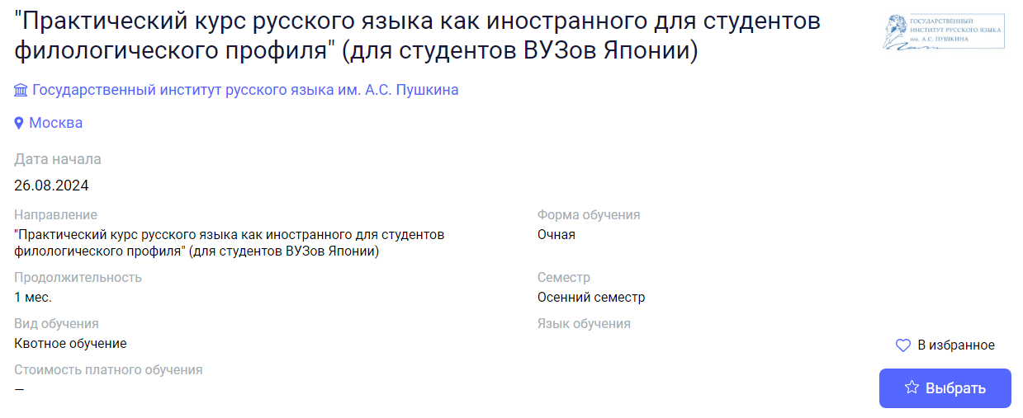
01.09.2024  (hybrid format) | 4 | Moscow | Moscow State Linguistic University | Russian as a Foreign Language. | Русский язык как иностранный. | https://education-in-russia.com/education-in-russia/programs/123337  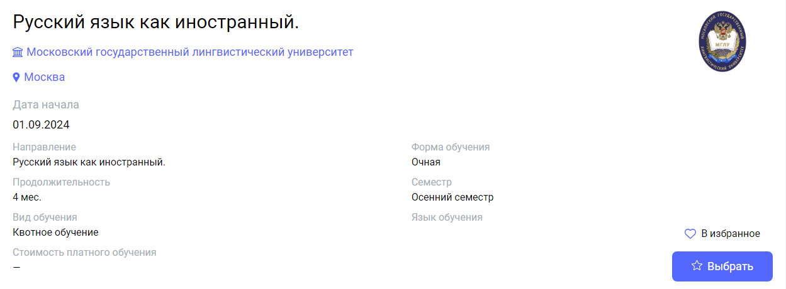
01.09.2024  (hybrid format) | 10 | Moscow | Moscow State Linguistic University | Russian as a Foreign Language. | Русский язык как иностранный. | https://education-in-russia.com/education-in-russia/programs/123335  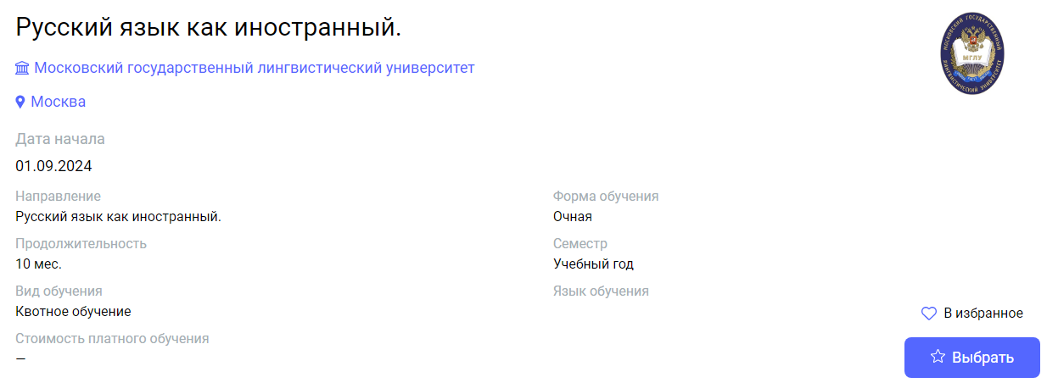
01.09.2024  (hybrid format) | 4 | Moscow | Moscow State Linguistic University | Russian as a Foreign Language. Advanced Level. | Русский язык как иностранный. Продвинутый уровень. | https://education-in-russia.com/education-in-russia/programs/123333  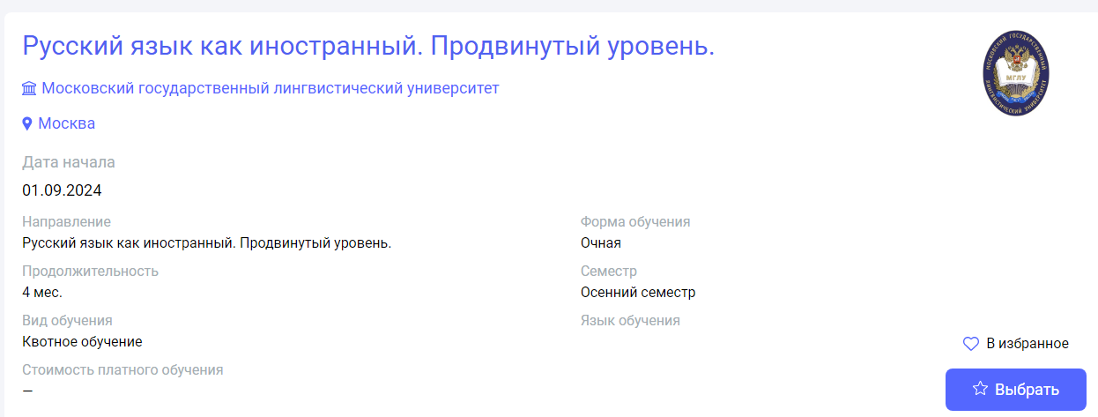
01.09.2024  (hybrid format) | 10 | Moscow | Moscow State Linguistic University | Russian as a Foreign Language. Advanced Level. | Русский язык как иностранный. Продвинутый уровень. | https://education-in-russia.com/education-in-russia/programs/123331  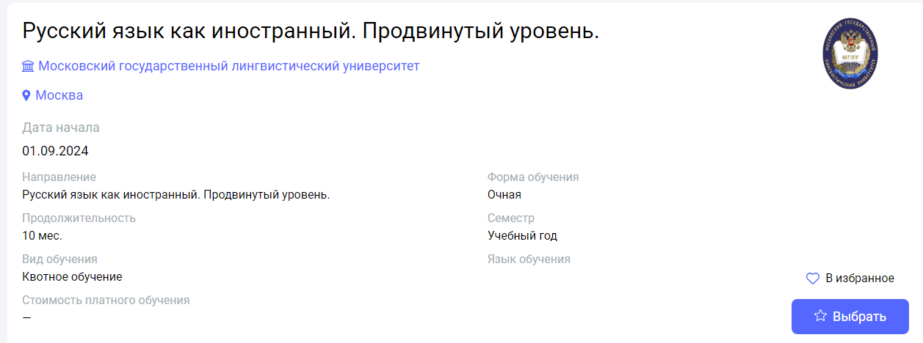
02.09.2024  (in-person) | 5 | Moscow | Pushkin State Russian Language Institute | "Practical course of Russian as a foreign language" | "Практический курс русского языка как иностранного" | https://education-in-russia.com/education-in-russia/programs/123419  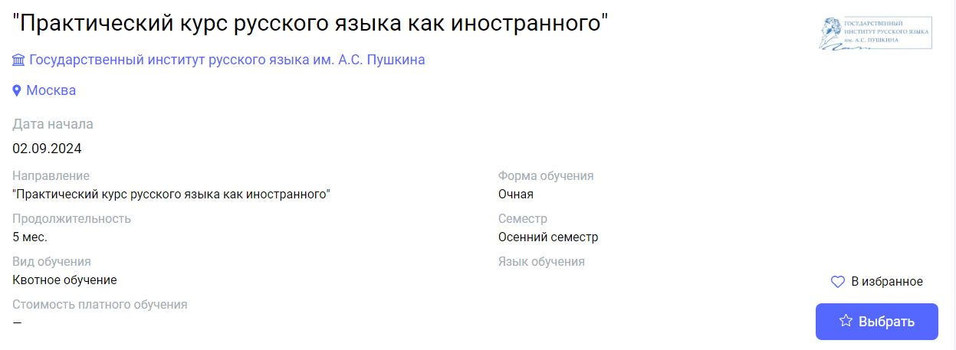
02.09.2024  (in-person) | 10 | Moscow | Pushkin State Russian Language Institute | "Practical course of Russian as a foreign language" | Практический курс русского языка как иностранного | https://education-in-russia.com/education-in-russia/programs/123447  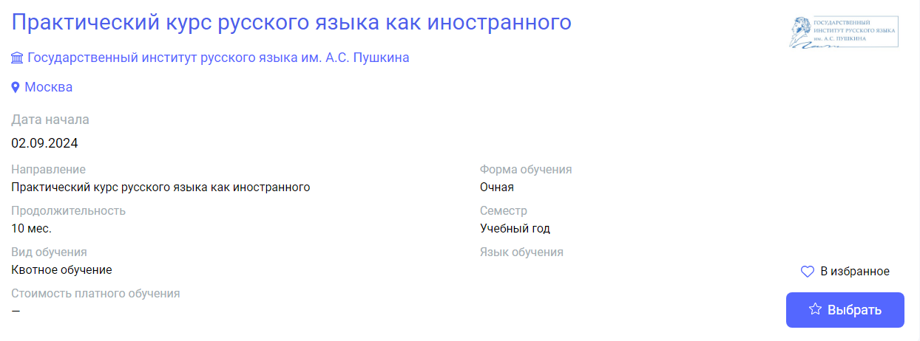
02.09.2024  (in-person) | 10 | Moscow | Pushkin State Russian Language Institute | "Practical Course of Russian as a Foreign Language for Students of Philological Faculties" | "Практический курс русского языка как иностранного для студентов филологического профиля" | https://education-in-russia.com/education-in-russia/programs/123438  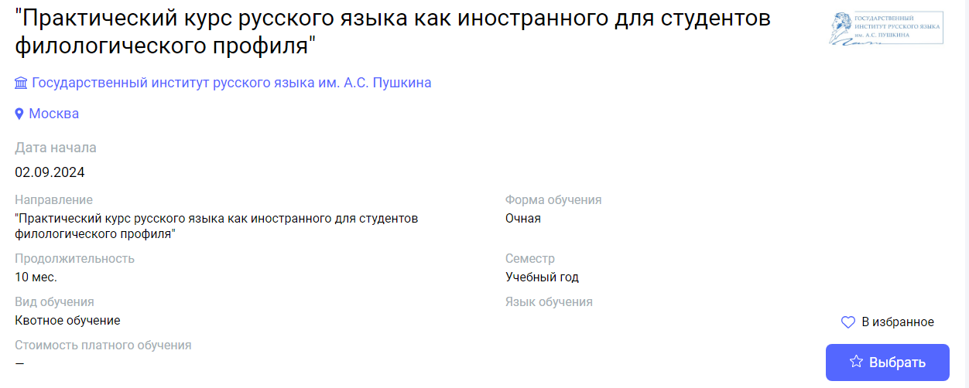
02.09.2024  (in-person) | 4 | Moscow | Pushkin State Russian Language Institute | "Practical Course of Russian as a Foreign Language for Students of Philological Faculties" | Практический курс русского языка как иностранного для студентов филологического профиля | https://education-in-russia.com/education-in-russia/programs/123435  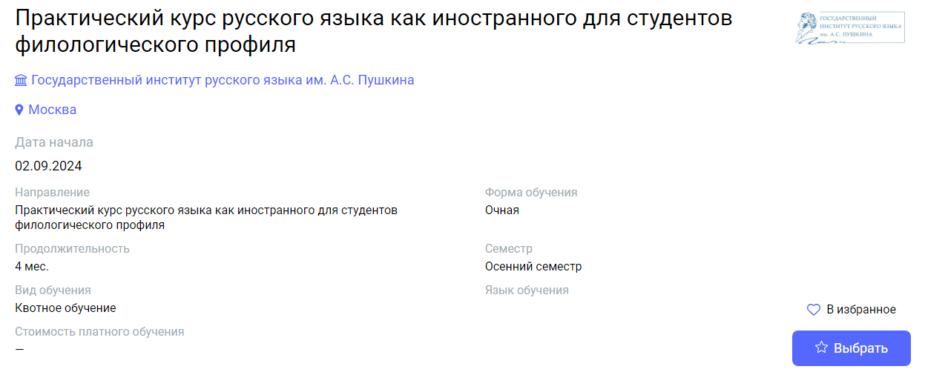
02.09.2024  (in-person) | 10 | Moscow | Pushkin State Russian Language Institute | "Russian as a Foreign Language (for students of Oil and Gas faculty)" | "Практический курс русского языка как иностранного (нефтегазовый профиль)" | https://education-in-russia.com/education-in-russia/programs/123432  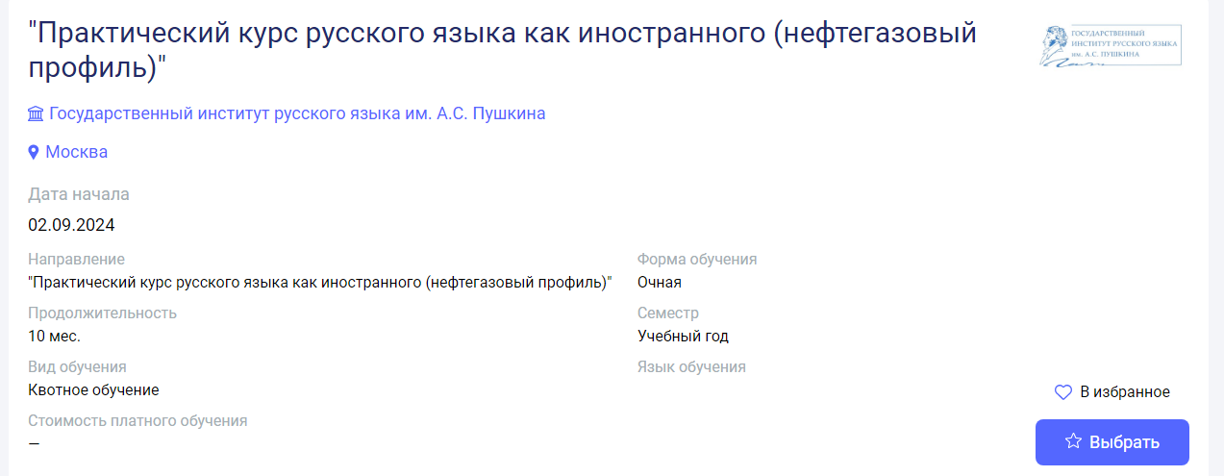
02.09.2024  (in-person) | 1 | Moscow | Pushkin State Russian Language Institute | "Practical course of Russian as a foreign language (September)" | Практический курс русского языка как иностранного (Сентябрь) | https://education-in-russia.com/education-in-russia/programs/123431  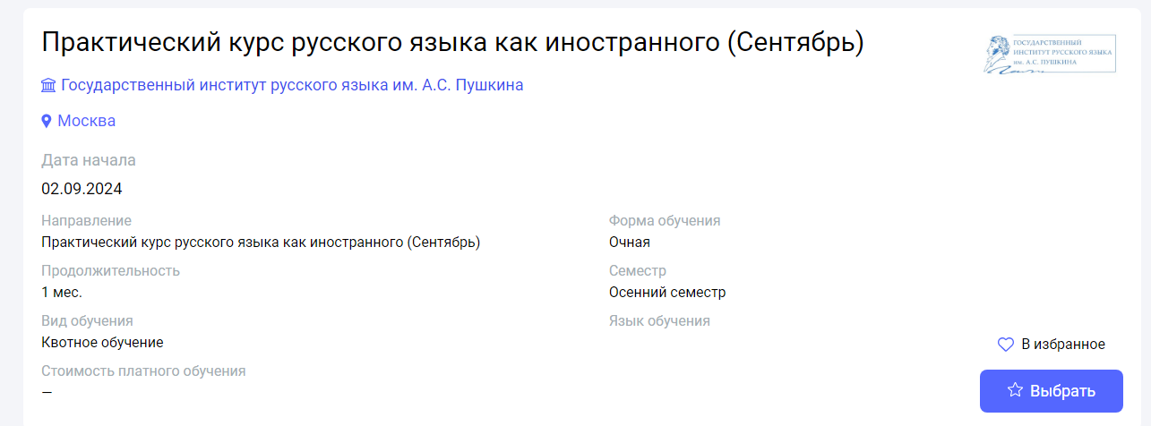
02.09.2024  (in-person) | 3 | Moscow | Pushkin State Russian Language Institute | "Practical course of Russian as a foreign language (September-November)" | Практический курс русского языка как иностранного (Сентябрь-Ноябрь) | https://education-in-russia.com/education-in-russia/programs/123430  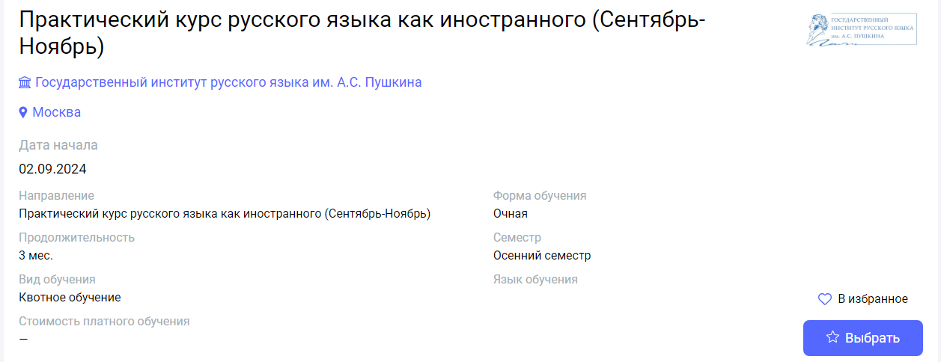
01.10.2024  (in-person) | 2 | Moscow | Pushkin State Russian Language Institute | "Practical Course of Russian as a Foreign Language for Students of Philological Faculties" | "Практический курс русского языка как иностранного для студентов филологического профиля" | https://education-in-russia.com/education-in-russia/programs/123440  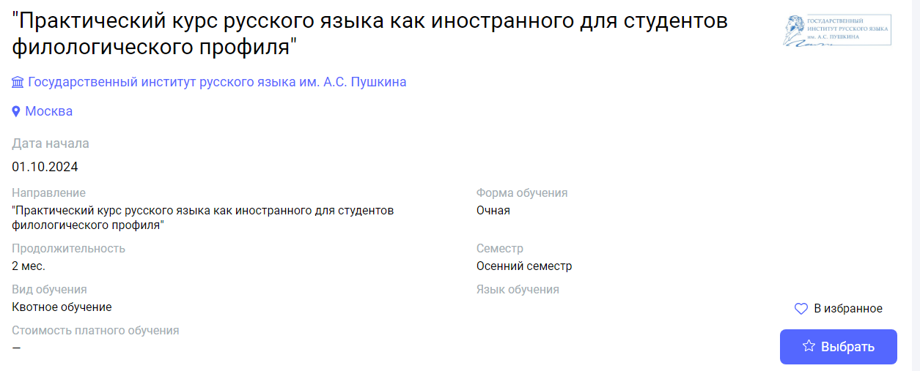
01.10.2024  (in-person) | 3 | Moscow | Pushkin State Russian Language Institute | Practical Course of Russian as a Foreign Language for Students of Philological Faculties | Практический курс русского языка как иностранного для студентов филологического профиля | https://education-in-russia.com/education-in-russia/programs/123436  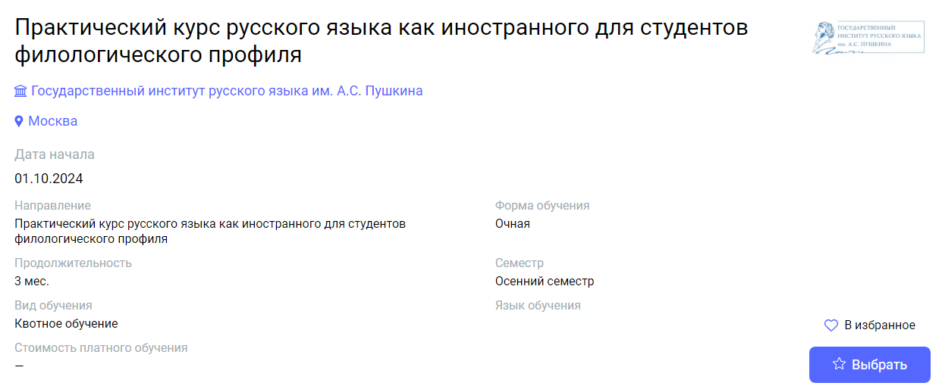
03.02.2025  (in-person) | 5 | Moscow | Pushkin State Russian Language Institute | "Practical course of Russian as a foreign language (5 months)" | "Практический курс русского языка как иностранного (5 месяцев)" | https://education-in-russia.com/education-in-russia/programs/123442  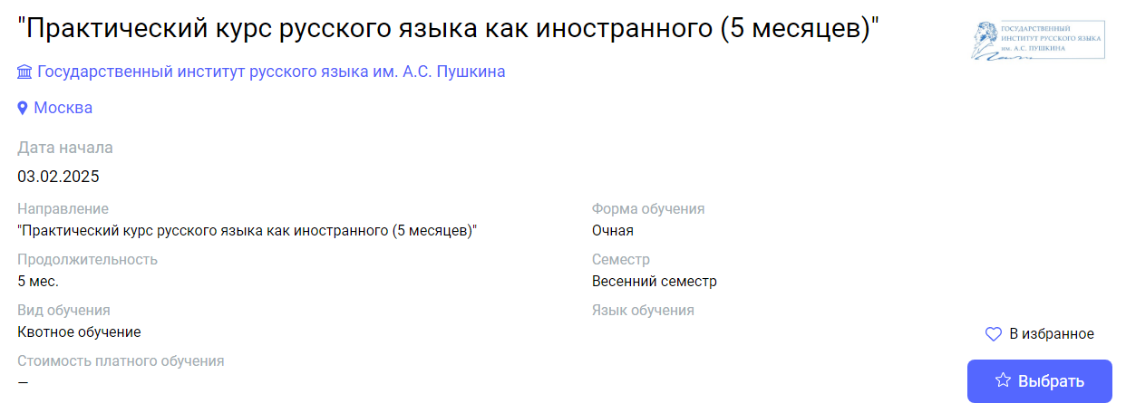
03.02.2025  (in-person) | 4 | Moscow | Pushkin State Russian Language Institute | "Practical Course of Russian as a Foreign Language (for Students of Philological Faculties)" | "Практический курс русского языка как иностранного (для студентов филологического профиля)" | https://education-in-russia.com/education-in-russia/programs?typeFilter=additional  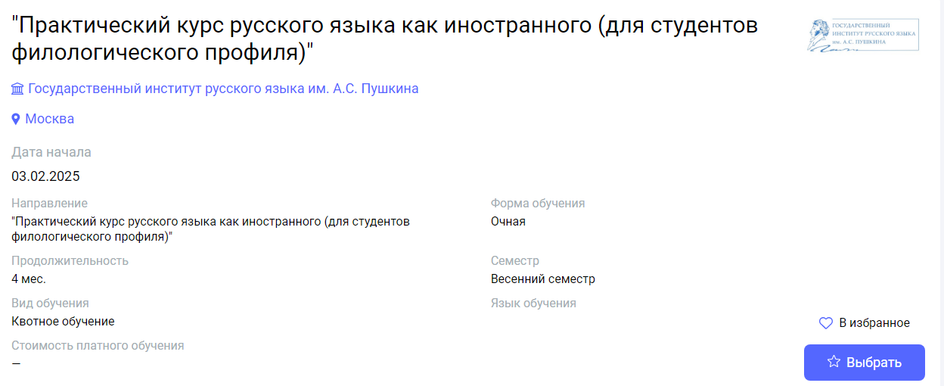
03.02.2025  (in-person) | 3 | Moscow | Pushkin State Russian Language Institute | "Practical Course of Russian as a Foreign Language for Students of Philological Faculties" | "Практический курс русского языка как иностранного для студентов филологического профиля" | https://education-in-russia.com/education-in-russia/programs/123439  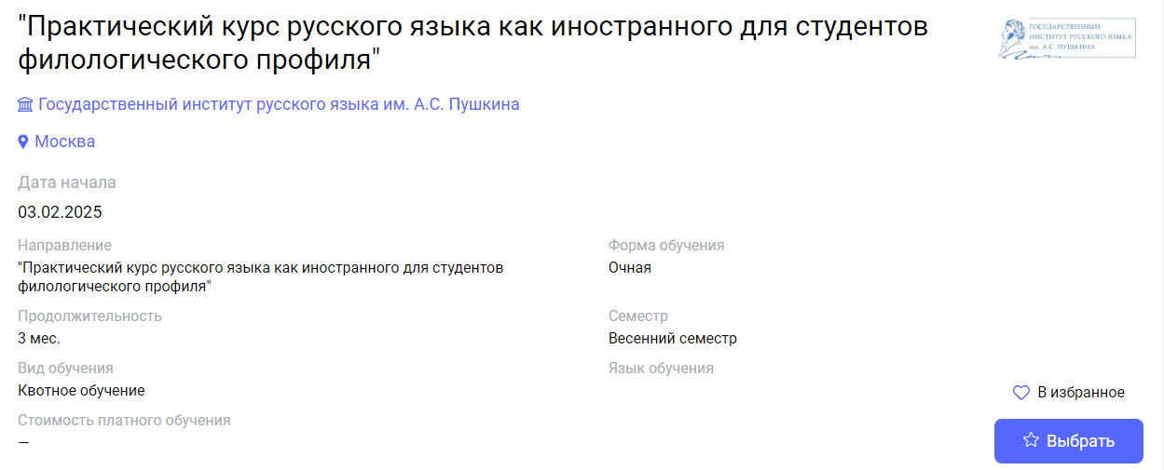
03.02.2025  (in-person) | 1 | Moscow | Pushkin State Russian Language Institute | Practical Course of Russian as a Foreign Language for Students of Philological Faculties | Практический курс русского языка как иностранного для студентов филологического профиля | https://education-in-russia.com/education-in-russia/programs/123437  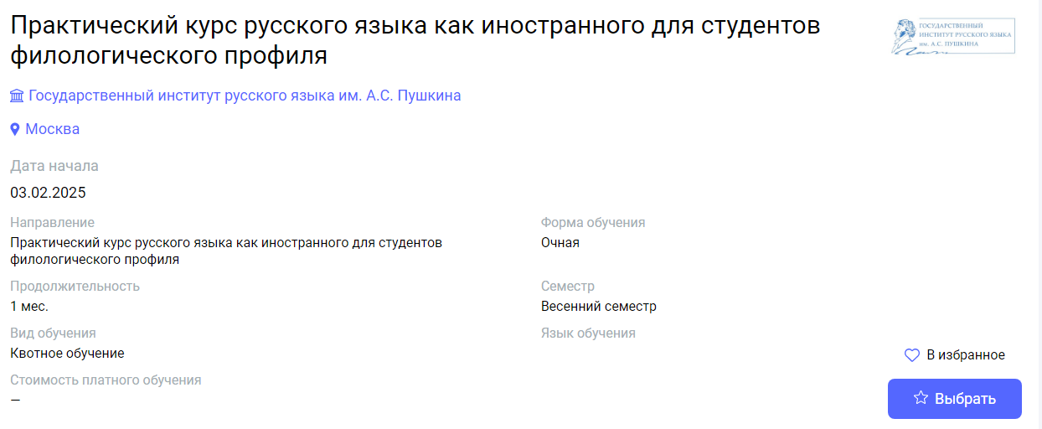
03.02.2025  (in-person) | 1 | Moscow | Pushkin State Russian Language Institute | "Practical course of Russian as a foreign language (February)" | Практический курс русского языка как иностранного (Февраль) | https://education-in-russia.com/education-in-russia/programs/123429  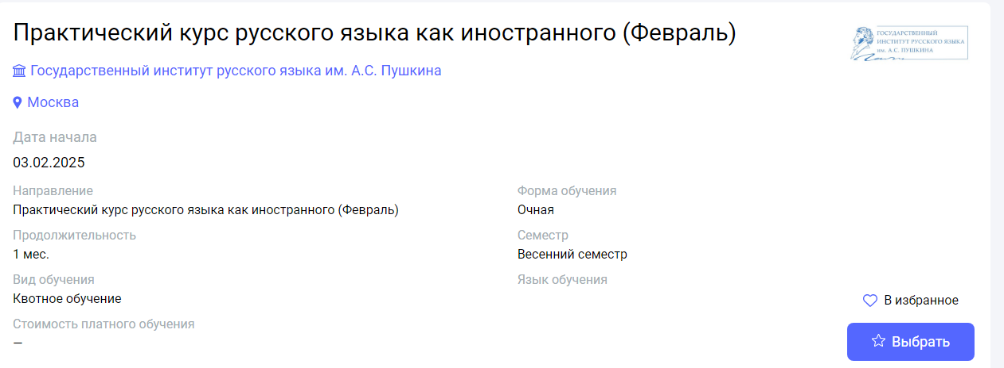
03.02.2025  (hybrid format) | 5 | Moscow | Moscow State Linguistic University | Russian as a Foreign Language. | Русский язык как иностранный. | https://education-in-russia.com/education-in-russia/programs/123336  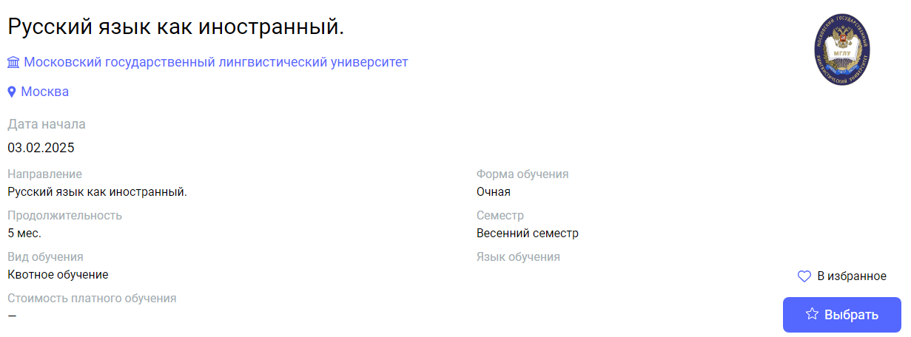
03.02.2025  (hybrid format) | 5 | Moscow | Moscow State Linguistic University | Russian as a Foreign Language. Advanced Level. | Русский язык как иностранный. Продвинутый уровень. | https://education-in-russia.com/education-in-russia/programs/123332  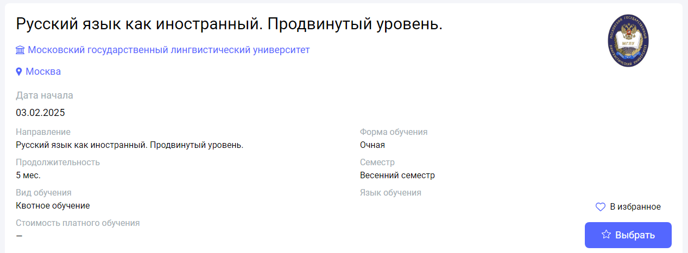
03.02.2025  (hybrid format) | 7 | Moscow | Peoples' Friendship University of Russia named after Patrice Lumumba | Russian language (medicine) | Русский язык (углубленный уровень: медико-биологический профиль) | https://education-in-russia.com/education-in-russia/programs/123200  