Regional level
Additional programs of Russian as a foreign language (in-person)
https://education-in-russia.com/education-in-russia/programs?typeFilter=additional
Start date | Duration (mth.) | City | University | Program name | Program name in Russian | Screenshot
07.08.2023 | 1 | Omsk | Omsk State Pedagogical University | Russian as a foreign language | Русский язык как иностранный | https://education-in-russia.com/education-in-russia/programs/123605  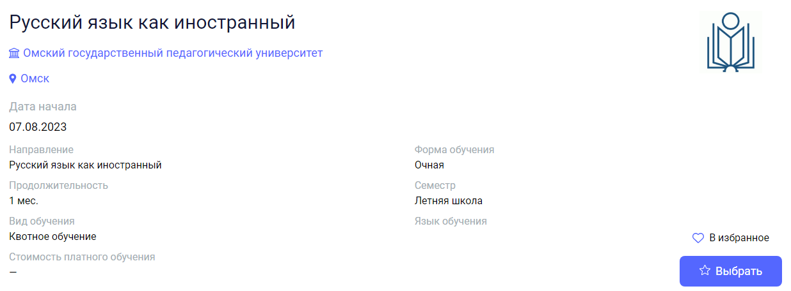
10.08.2023 | 1 | Rostov-on-Don | Southern Federal University | Intensive Russian language course for foreign teachers of Russian language | Интенсивный курс русского языка для зарубежных преподавателей-русистов | https://education-in-russia.com/education-in-russia/programs/123223  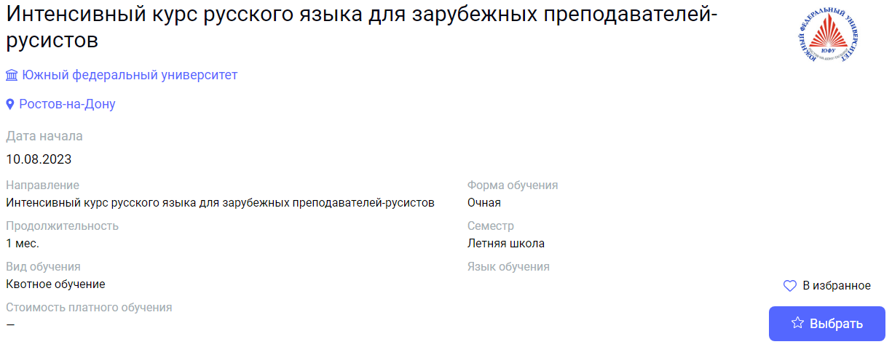
14.08.2023 | 1 | Ivanovo | Ivanovo State University | Linguistics and country studies | Лингвострановедение | https://education-in-russia.com/education-in-russia/programs/123400  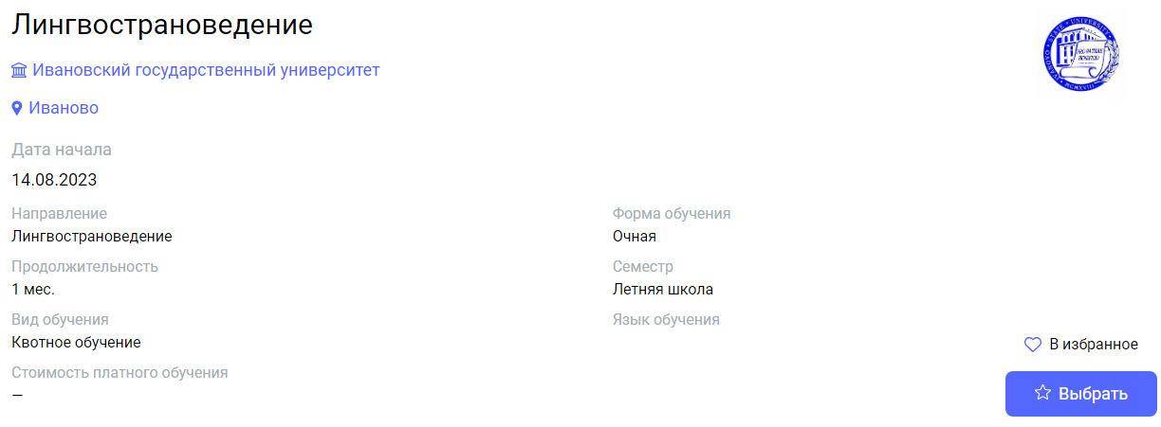
01.09.2023 | 5 | Ivanovo | Ivanovo State University | Linguoculturology | Лингвокультурология | https://education-in-russia.com/education-in-russia/programs/123276  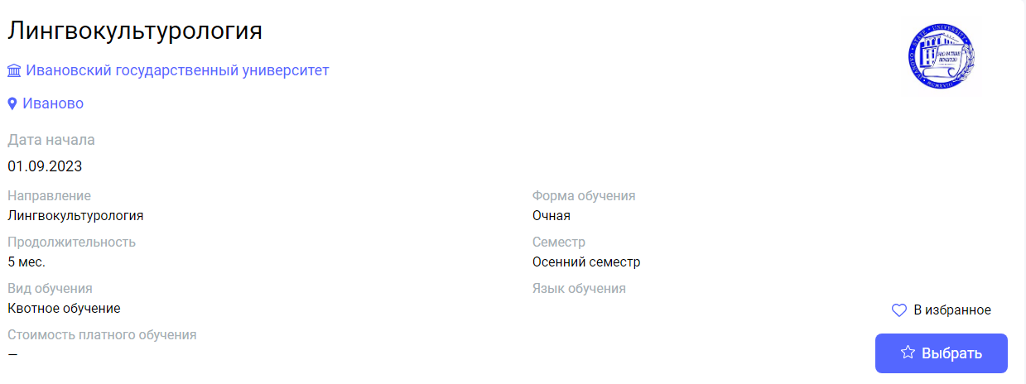
01.09.2023 | 10 | Ivanovo | Ivanovo State University | Linguoculturology | Лингвокультурология | https://education-in-russia.com/education-in-russia/programs/123402  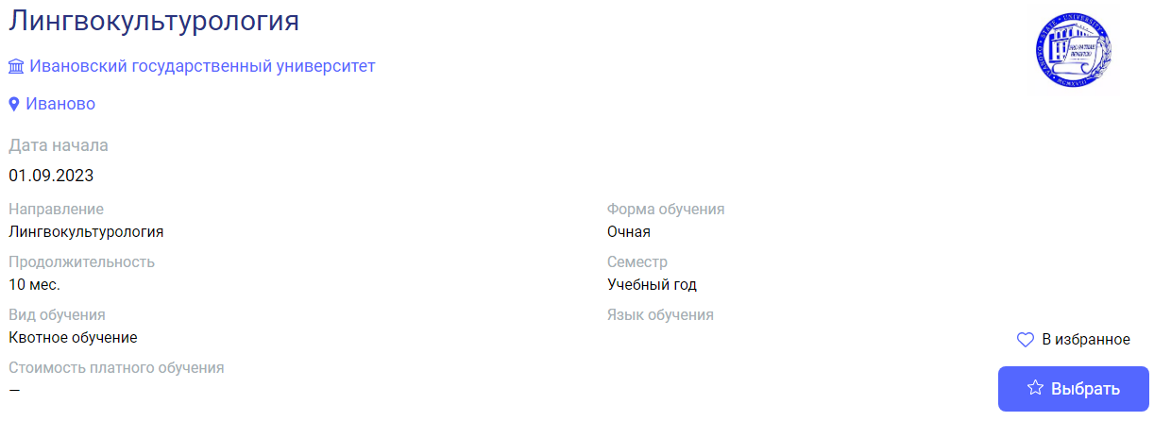
01.09.2023 | 10 | Ivanovo | Ivanovo State University | Linguometodic foundations of Russian as a foreign language | Лингвометодические основы русского языка как иностранного | https://education-in-russia.com/education-in-russia/programs/123401  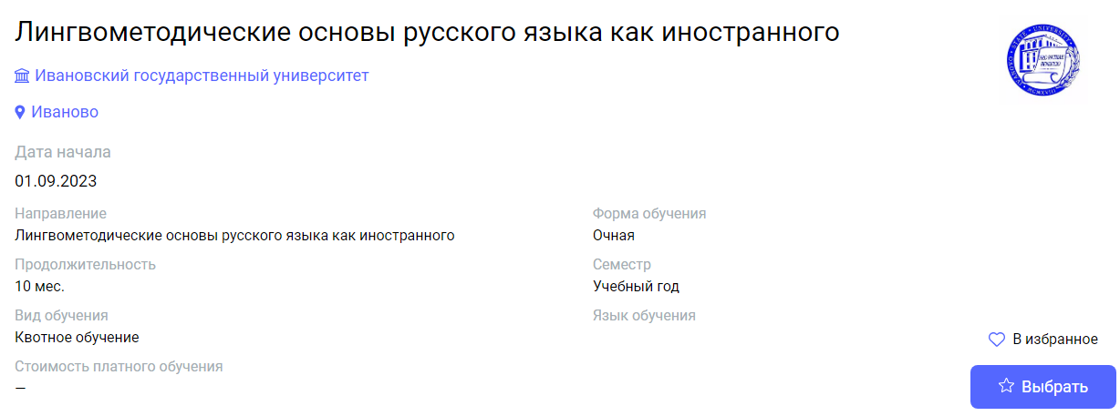
01.09.2023 | 10 | Ivanovo | Ivanovo State University | Russian language and culture in the modern world | Русский язык и культура в современном мире | https://education-in-russia.com/education-in-russia/programs/123398  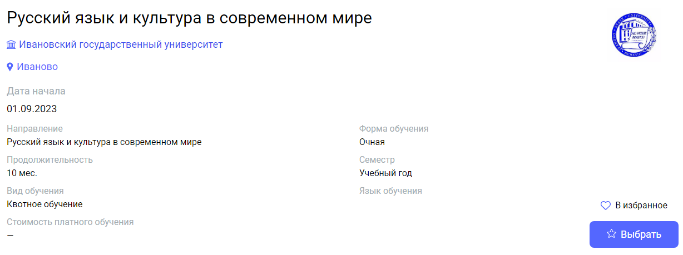
01.09.2023 | 5 | Ivanovo | Ivanovo State University | Russian as foreign language | Русский язык как иностранный | https://education-in-russia.com/education-in-russia/programs/123397  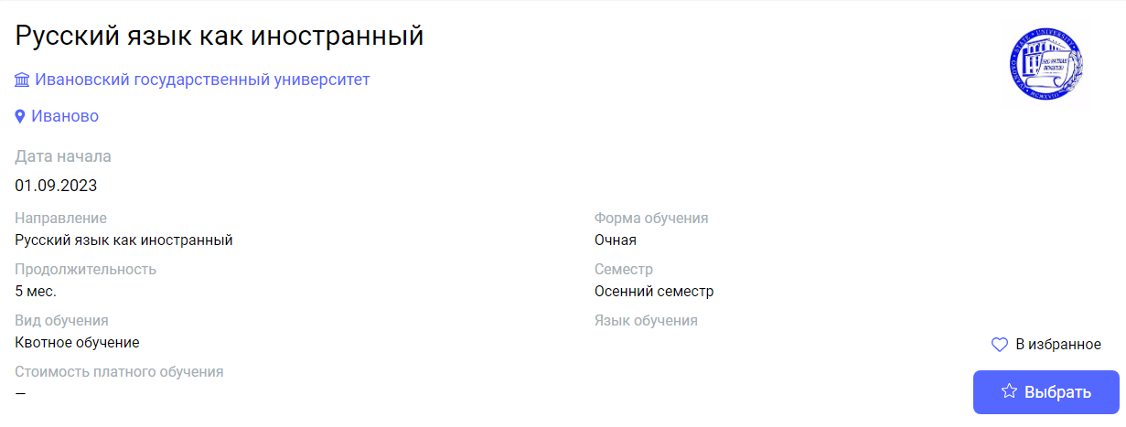
18.09.2023,  05.02.2024 | 8 | Penza | Penza State University of Architecture and Construction | Russian as a foreign language: an intensive course of communication-oriented study of the Russian language by foreign citizens to prepare for higher education in the Humanities | Русский язык как иностранный: интенсивный курс коммуникативной направленности изучения русского языка иностранными гражданами для подготовки к обучению в вузе по гуманитарному профилю | https://education-in-russia.com/education-in-russia/programs/123680  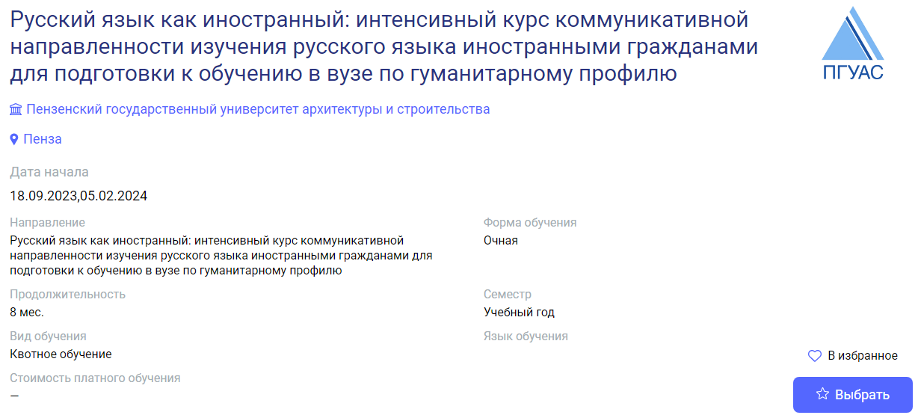
18.09.2023,  08.01.2024 | 8 | Penza | Penza State University of Architecture and Construction | Russian as a foreign language: an intensive course of communication-oriented study of the Russian language by foreign citizens to prepare for higher education in the Humanities | Русский язык как иностранный: интенсивный курс коммуникативной направленности изучения русского языка иностранными гражданами для подготовки к обучению в вузе по техническому профилю | https://education-in-russia.com/education-in-russia/programs/123679  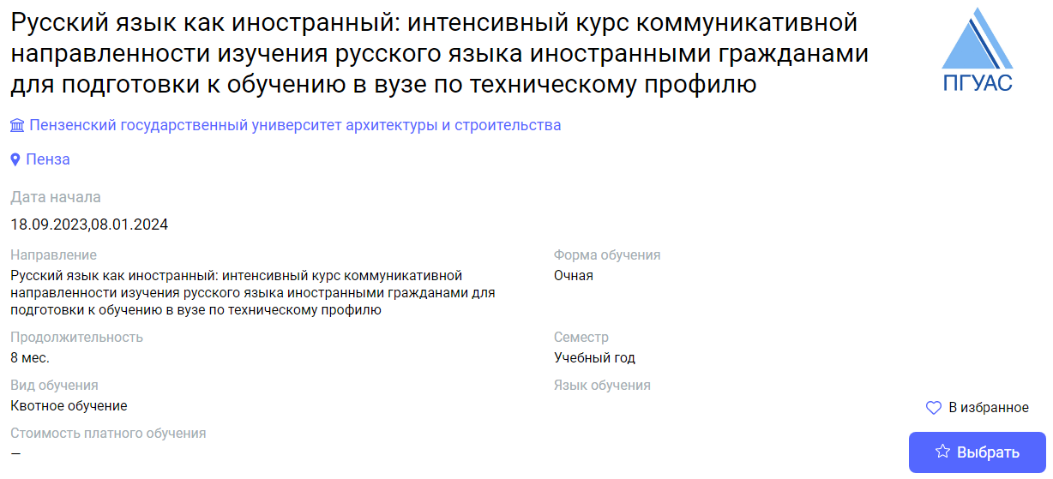
01.10.2023 | 9 | Komsomolsk-na-Amure | Komsomolsk-na-Amure State University | Russian as foreign language (humanitarian) | Русский язык как иностранный (гуманитарный профиль) | https://education-in-russia.com/education-in-russia/programs/123686  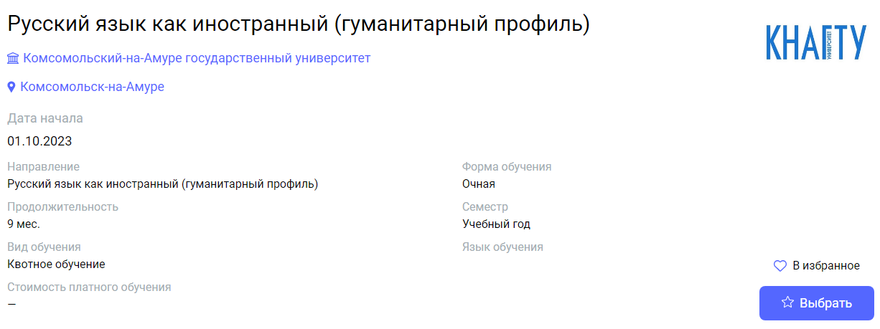
01.10.2023 | 9 | Komsomolsk-na-Amure | Komsomolsk-na-Amure State University | Russian as foreign language (technical) | Русский язык как иностранный (инженерно-технический профиль) | https://education-in-russia.com/education-in-russia/programs/123685  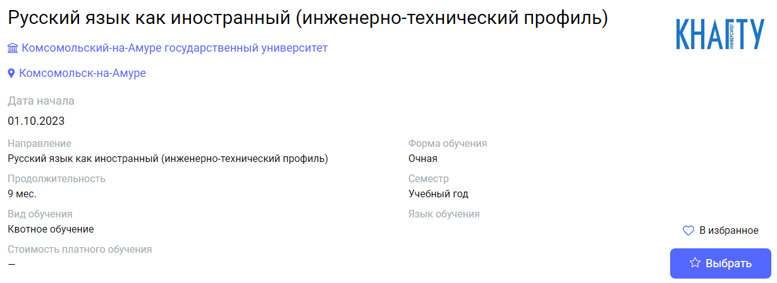
02.10.2023 | 8 | Bryansk | Bryansk State Technological University of Engineering | Russian as a foreign language | Русский как иностранный язык | https://education-in-russia.com/education-in-russia/programs/123458  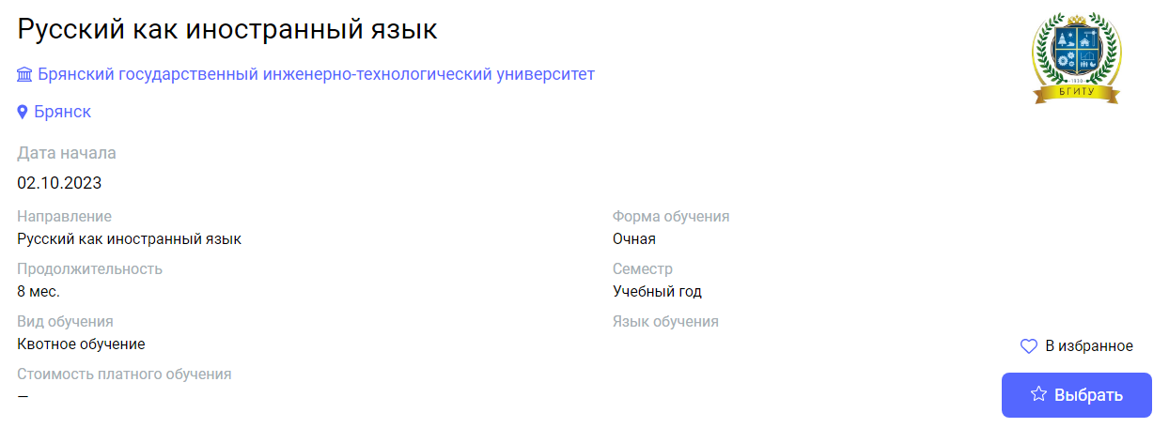
02.10.2023 | 6 | Murmansk | Murmansk Arctic State University | Russian as a foreign language | Русский язык как иностранный | https://education-in-russia.com/education-in-russia/programs/123486  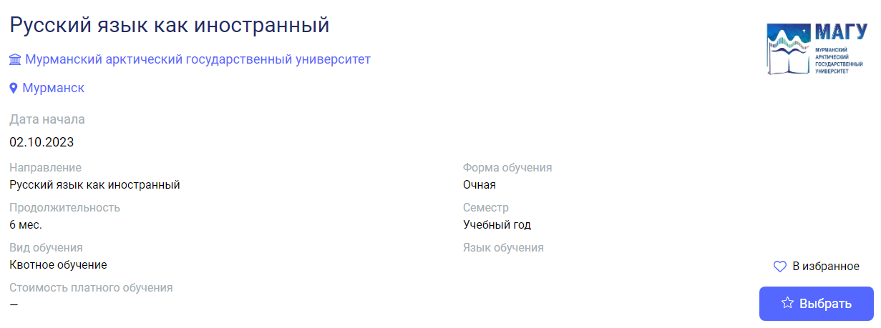
02.10.2023 | 8 | Bryansk | Bryansk State Technological University of Engineering | Russian as a foreign language | Русский как иностранный язык | https://education-in-russia.com/education-in-russia/programs/123458
02.10.2023 | 8 | Shadrinsk | Shadrinsk State Pedagogical University | Russian as foreign language | Русский язык как иностранный | https://education-in-russia.com/education-in-russia/programs/123241  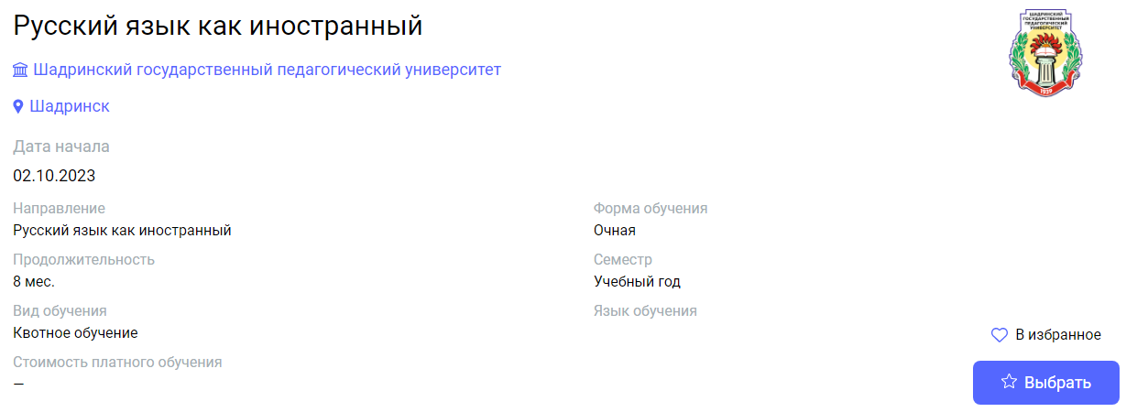
09.10.2023 | 1 | Pskov | Pskov State University | Russian as foreign language | Русский язык как иностранный | https://education-in-russia.com/education-in-russia/programs/123322  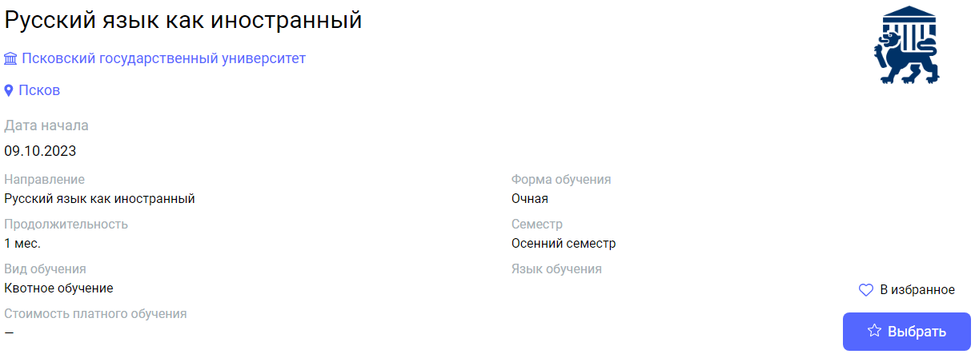
01.11.2023 | 8 | Yekaterinburg | Ural State Pedagogical University | Russian as a foreign language | Русский язык как иностранный | https://education-in-russia.com/education-in-russia/programs/123213  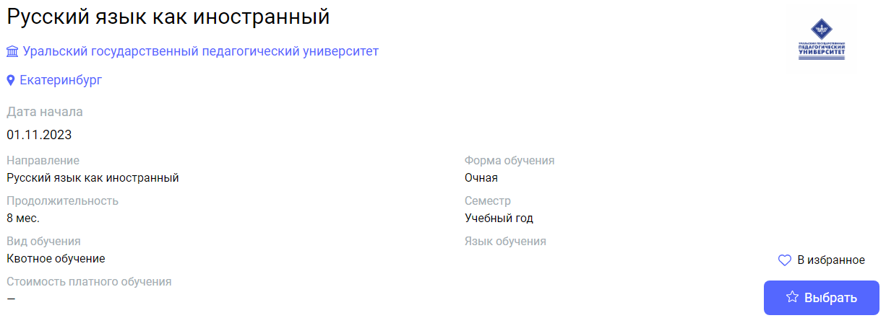
10.01.2024 | 1 | Belgorod | Belgorod State Technological University named after V.G.Shukhov | Winter linguistic school | Зимняя языковая школа | https://education-in-russia.com/education-in-russia/programs/123598  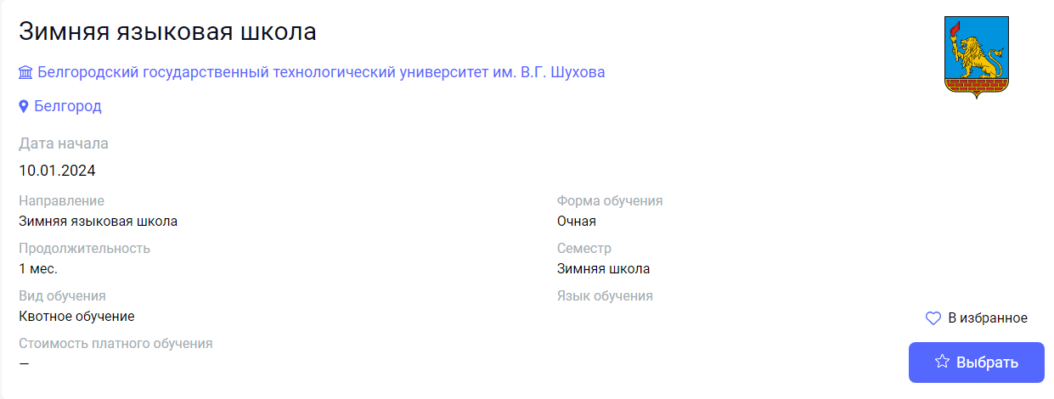
15.01.2024,  26.08.2024,  13.01.2025 | 4 | Irkutsk | Irkutsk National Research Technical University | Comparative linguodidactics and teaching of Russian as a foreign language | Компаративная лингводидактика и преподавание русского языка как иностранного | https://education-in-russia.com/education-in-russia/programs/123601  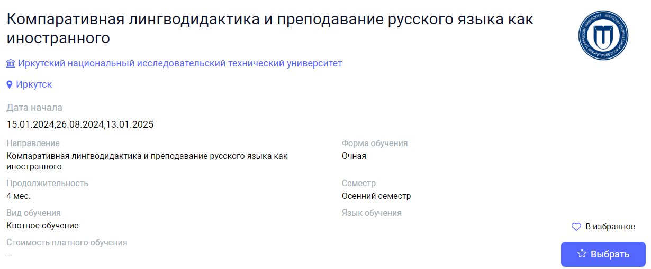
01.02.2024 | 5 | Ivanovo | Ivanovo State University | Russian language and culture | Русский язык и культура | https://education-in-russia.com/education-in-russia/programs/123398  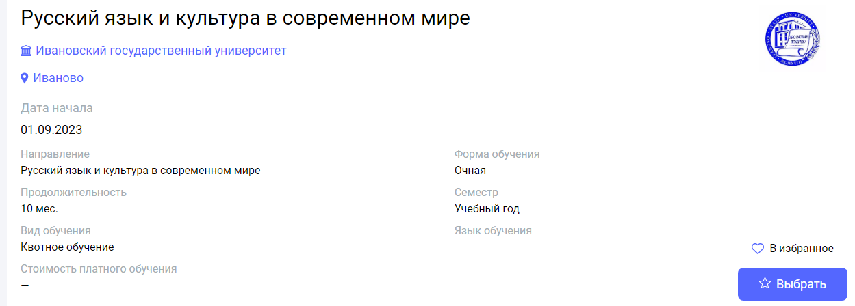
05.02.2024 | 1 | Kursk | Kursk State University | Russian language winter school | Зимняя школа по русскому языку как иностранному | https://education-in-russia.com/education-in-russia/programs/123198  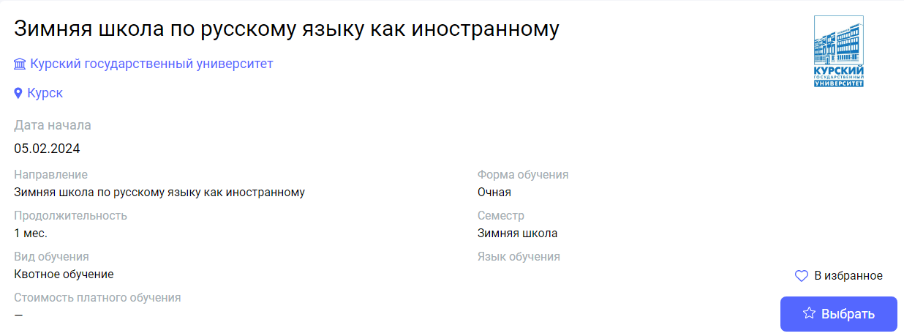
05.02.2024 | 1 | Ivanovo | Ivanovo State University | Linguoculturology | Лингвокультурология | https://education-in-russia.com/education-in-russia/programs/123308  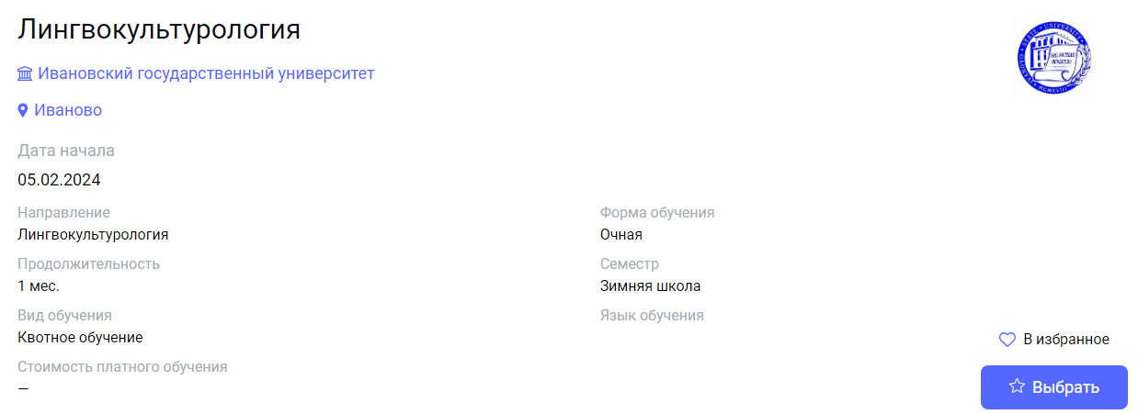
19.02.2024 | 1 | Arkhangelsk | Northern (Arctic) Federal University named after  M.V. Lomonosov | Winter School of Russian language and culture | Зимняя школа русского языка и культуры | https://education-in-russia.com/education-in-russia/programs/123457  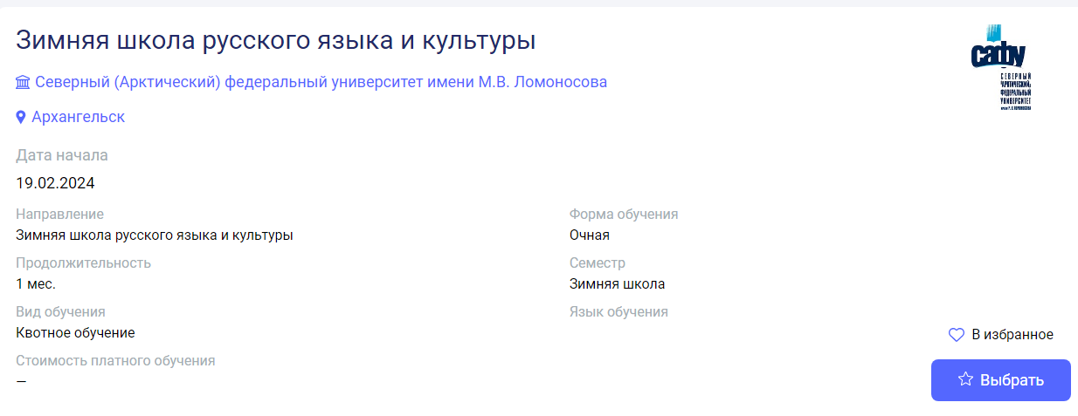
01.04.2024 | 1 | Pskov | Pskov State University | Russian world and Russian human in language and culture | Русский мир и русский человек в языке и культуре | https://education-in-russia.com/education-in-russia/programs/123321  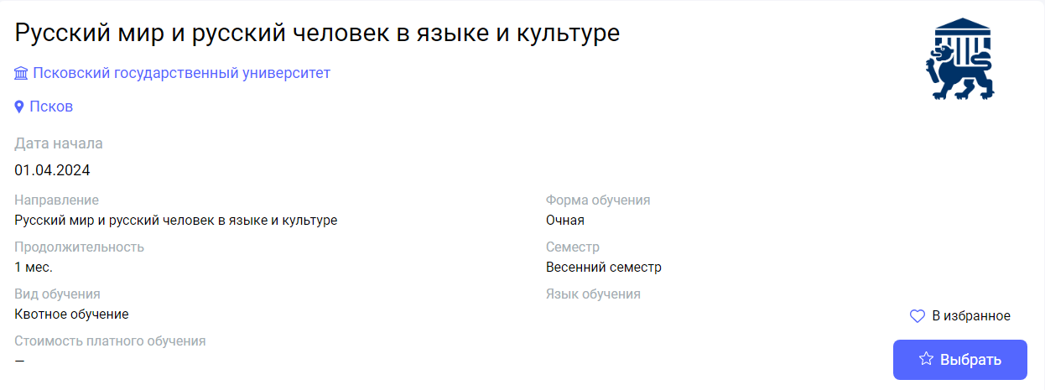
17.06.2024 | 1 | Arkhangelsk | Northern (Arctic) Federal University named after  M.V. Lomonosov | Summer School of Russian language and culture | Летняя школа русского языка и культуры | https://education-in-russia.com/education-in-russia/programs/123456  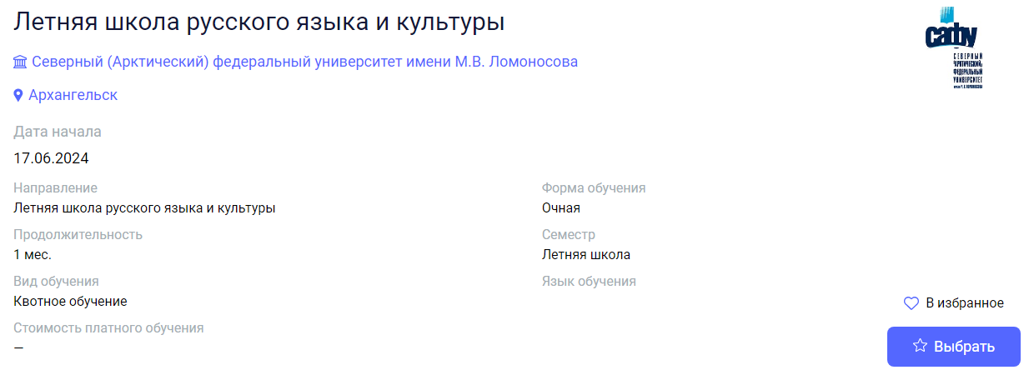
01.07.2024 | 1 | Belgorod | Belgorod State Technological University named after V.G.Shukhov | Summer language school | Летняя языковая школа | https://education-in-russia.com/education-in-russia/programs/123597  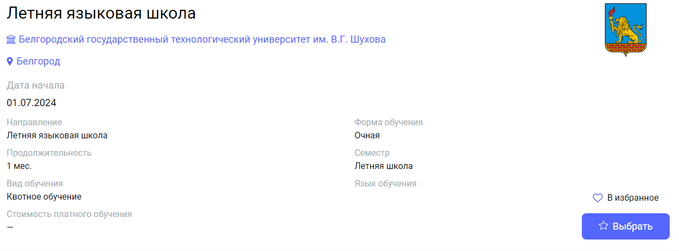
01.07.2024 | 1 | Belgorod | Belgorod State Technological University named after V.G.Shukhov | Intercultural communication | Межкультурная коммуникация | https://education-in-russia.com/education-in-russia/programs/123120  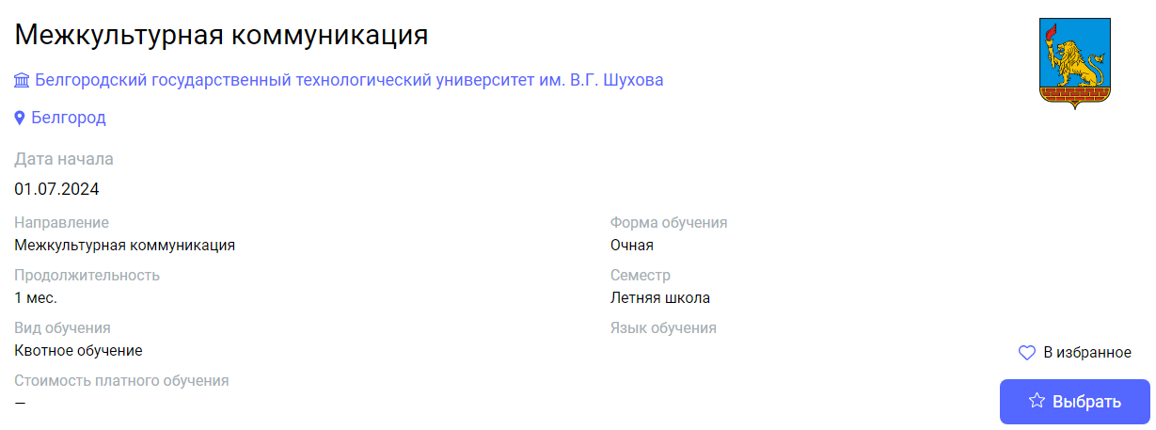
01.07.2024 | 2 | Bryansk | Bryansk State Technological University of Engineering | Russian as a foreign language | Русский как иностранный язык | https://education-in-russia.com/education-in-russia/programs/123459  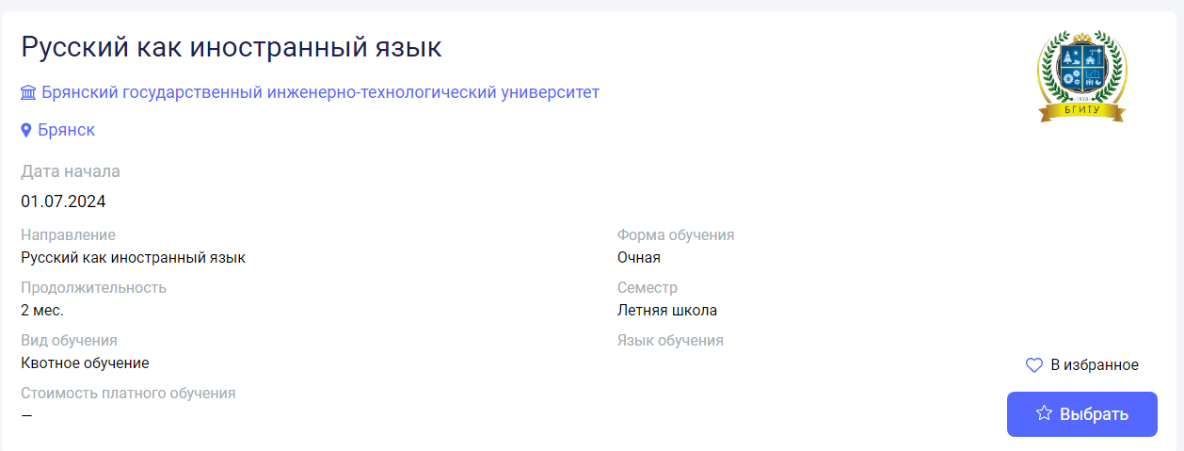
01.07.2024,  29.07.2024 | 1 | Irkutsk | Irkutsk National Research Technical University | Russian as a Foreign Language in Higher Engineering School: Content Integration, Digitalization, Assessment | Русский язык как иностранный в высшей инженерной школе: интеграция контента, цифровизация, оценивание | https://education-in-russia.com/education-in-russia/programs/123599  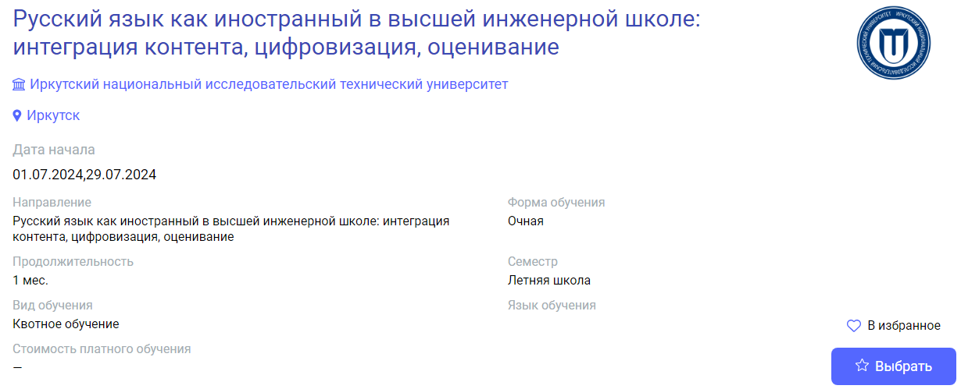
08.07.2024 | 1 | Nizhny Novgorod | National Research Lobachevsky State University of Nizhny Novgorod (Lobachevsky University) | International Summer School "Russian Summer" | Международная летняя школа "Лето по-русски" | https://education-in-russia.com/education-in-russia/programs/123324  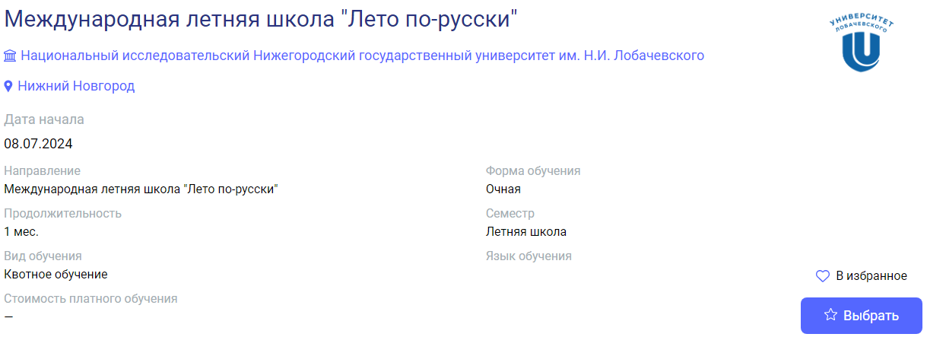
01.08.2024 | 1 | Kazan | Kazan (Volga region) Federal University | Summer School of Russian as a Foreign Language | Летняя школа русского языка как иностранного. | https://education-in-russia.com/education-in-russia/programs/123571  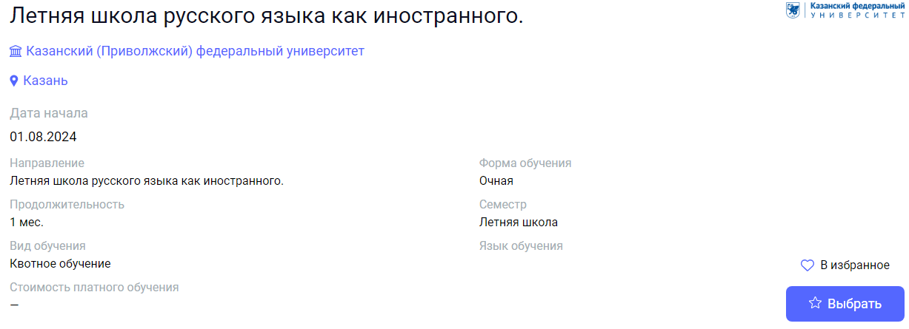
01.08.2024 | 1 | Ufa | Ufa University of  Science and Technology | Russian language as foreign | Русский язык как иностранный | https://education-in-russia.com/education-in-russia/programs/123602  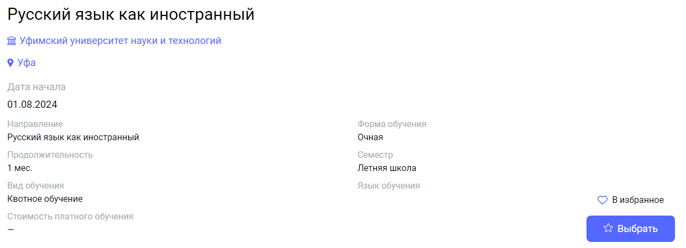
05.08.2024 | 0,5 | Irkutsk | Irkutsk State University | Summer school of russian for beginners | Летняя школа русского языка начального уровня | https://education-in-russia.com/education-in-russia/programs/123645  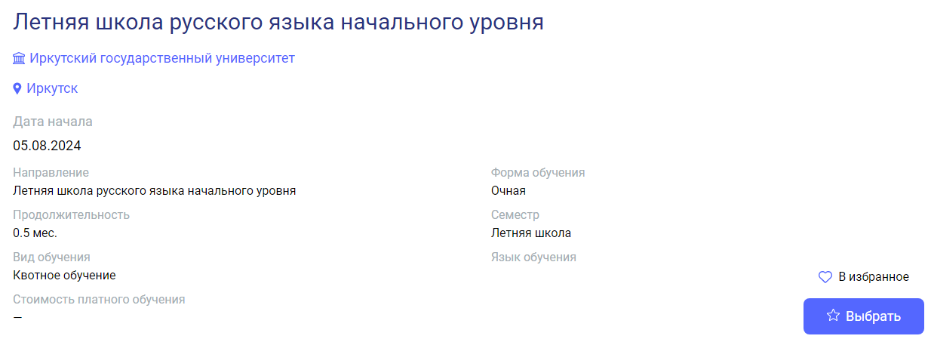
05.08.2024 | 0,5 | Irkutsk | Irkutsk State University | Summer school of advanced russian | Летняя школа русского языка продвинутого уровня | https://education-in-russia.com/education-in-russia/programs/123644  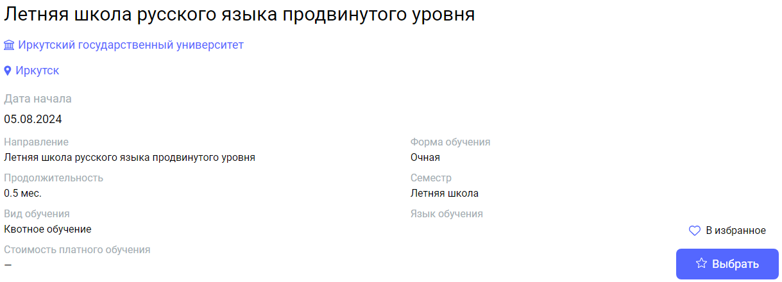
01.09.2024 | 9 | Vologda | Vologda State University | Preparatory year | Подготовка иностранных граждан к освоению основных профессиональных образовательных программ на русском языке | https://education-in-russia.com/education-in-russia/programs/123146  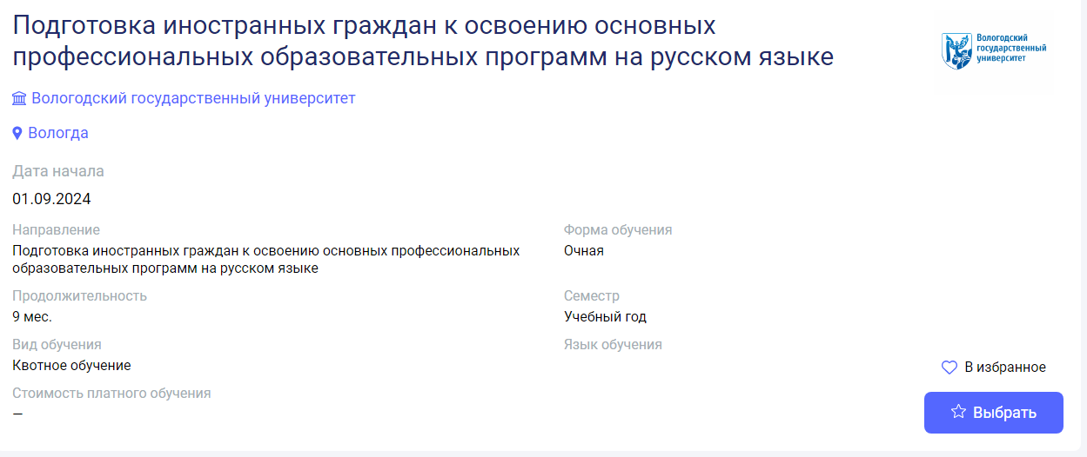
01.09.2024 | 9 | Vologda | Vologda State University | Russian as a Foreign Language | Русский язык как иностранный, от А1 - B1 | https://education-in-russia.com/education-in-russia/programs/123145  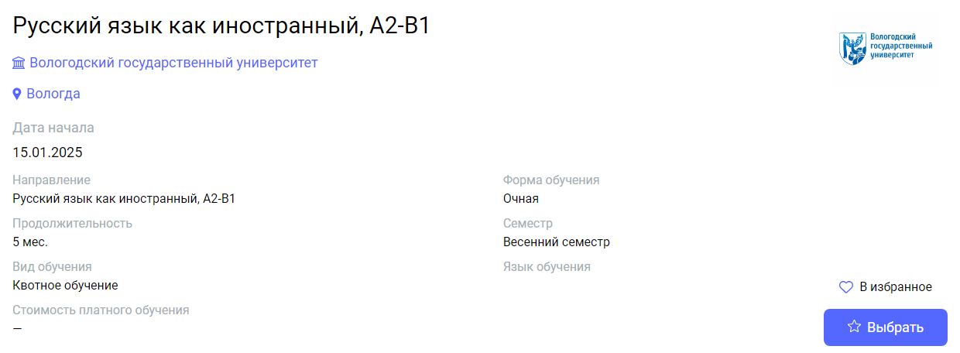
02.09.2024 | 9 | Irkutsk | Baikal State University | Russian for Foreign Students | Русский язык для иностранцев | https://education-in-russia.com/education-in-russia/programs/123220  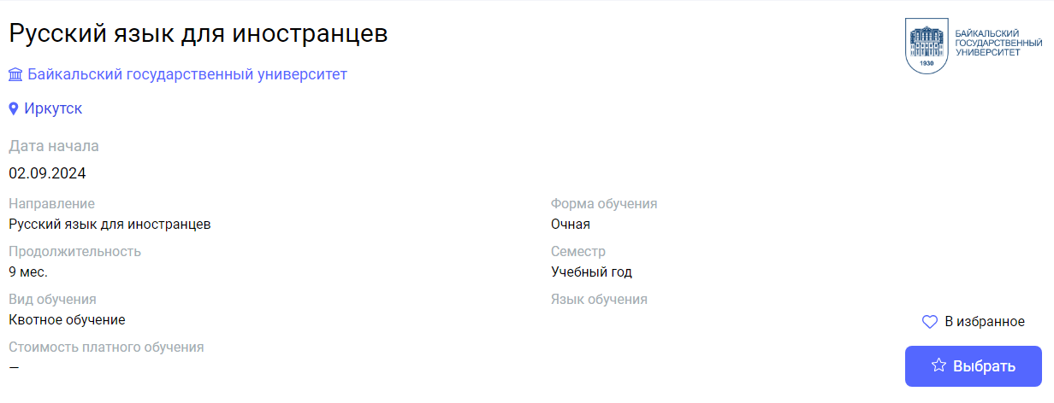
02.09.2024 | 4 | Irkutsk | Irkutsk State University | Russian as a foreign language | Русский язык как иностранный | https://education-in-russia.com/education-in-russia/programs/123643  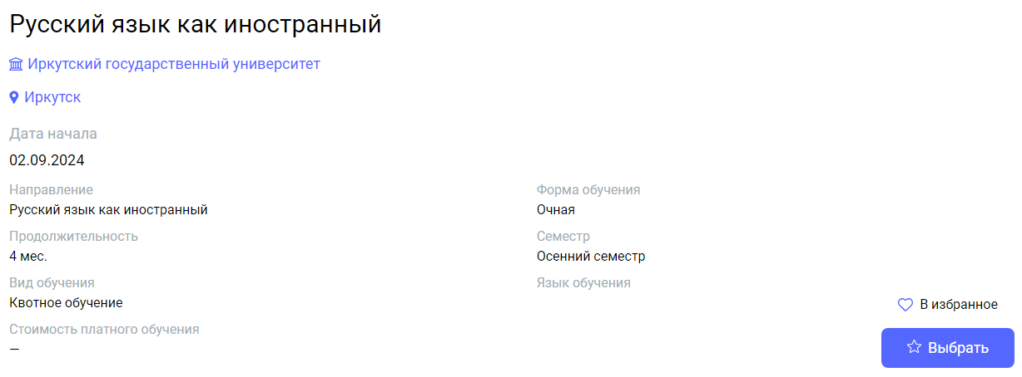
02.09.2024 | 10 | Irkutsk | Irkutsk State University | Russian as a foreign language | Русский язык как иностранный | https://education-in-russia.com/education-in-russia/programs/123641  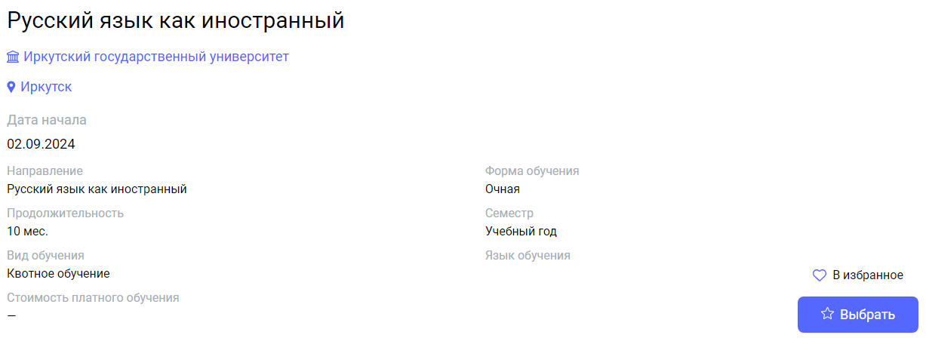
02.09.2024 | 12 | Krasnoyarsk | Krasnoyarsk State Pedagogical University named after V.P.Astafiev | Russian as a foreign language | Русский как иностранный | https://education-in-russia.com/education-in-russia/programs/123487  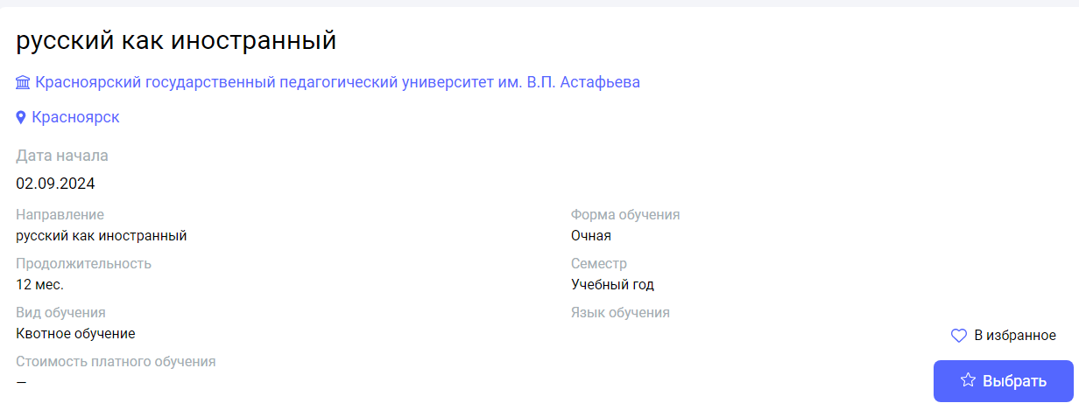
02.09.2024 | 1 | Kursk | Kursk State University | Russian language summer school | Летняя школа по русскому языку как иностранному | https://education-in-russia.com/education-in-russia/programs/123214  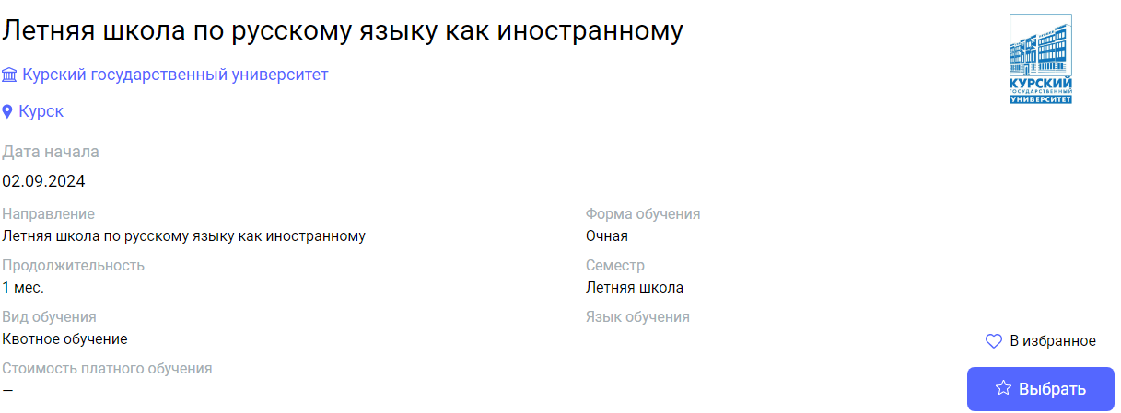
02.09.2024 | 10 | Tula | Tula State  Lev Tolstoy Pedagogical University | Russian Language and Literature: Practice-oriented Course | Русский язык и литература: практико-ориентированный курс | https://education-in-russia.com/education-in-russia/programs/123651  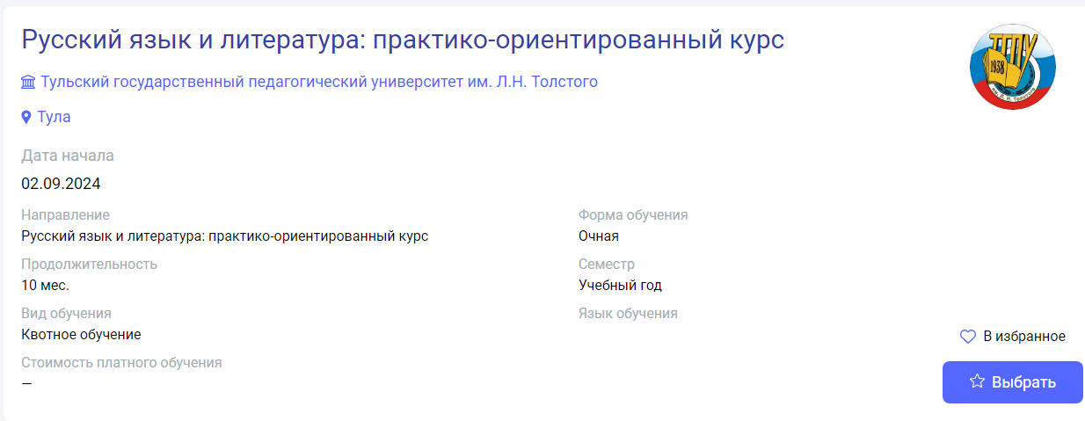
09.09.2024 | 9 | Yuzhno-Sakhalinsk | Sakhalin State University | Russian language (elementary certification level. Basic certification level. First certification level) | Русский язык как иностранный (Элементарный уровень. Базовый уровень. Первый сертификационный уровень) | https://education-in-russia.com/education-in-russia/programs/123452  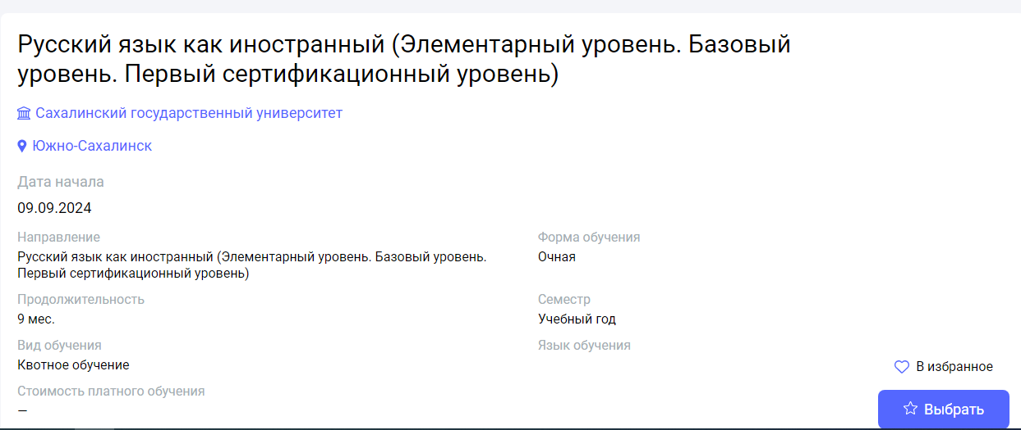
15.09.2024,  30.09.2024,  15.02.2025 | 4,5 | Nizhny Novgorod | Linguistics University of Nizhny Novgorod | The Russian Language and Culture (for foreign citizens who study Russian as a foreign language for various purposes) | Дополнительная общеобразовательная программа "Русский язык и культура России" (для иностранных граждан, изучающих русский язык как иностранный для разных целей) | https://education-in-russia.com/education-in-russia/programs/123519  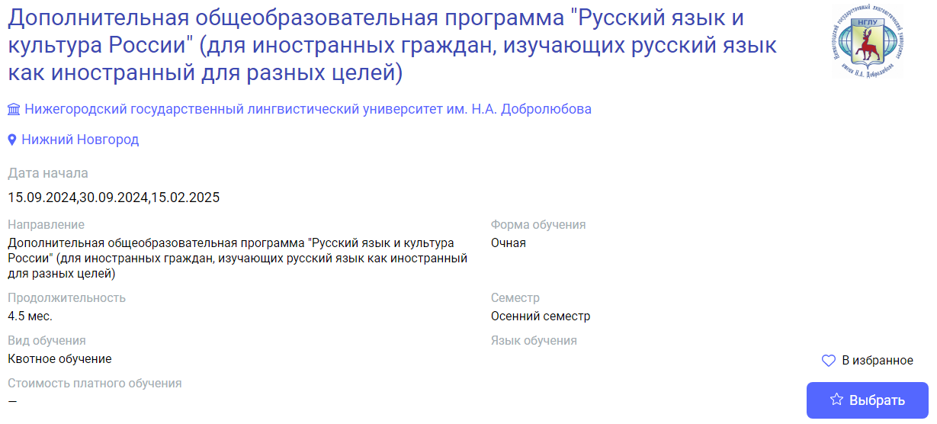
15.09.2024,  30.09.2024 | 9 | Nizhny Novgorod | Linguistics University of Nizhny Novgorod | The Russian Language and Russian Culture (for foreign citizens who study Russian as a foreign language for various purposes) | Дополнительная общеобразовательная программа "Русский язык и культура России" (для иностранных граждан, изучающих русский язык как иностранный для разных целей) | https://education-in-russia.com/education-in-russia/programs/123518  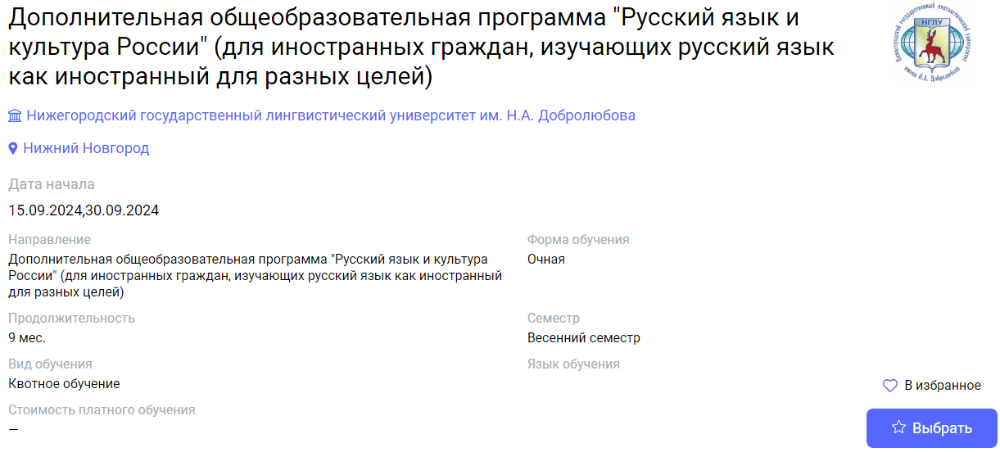
01.10.2024 | 10 | Nizhny Novgorod | Nizhny Novgorod State University of Architecture and Civil Engineering | Preparation for the main professional educational program of higher education | Подготовка к обучению по основной профессиональной образовательной программе высшего образования | https://education-in-russia.com/education-in-russia/programs/123219  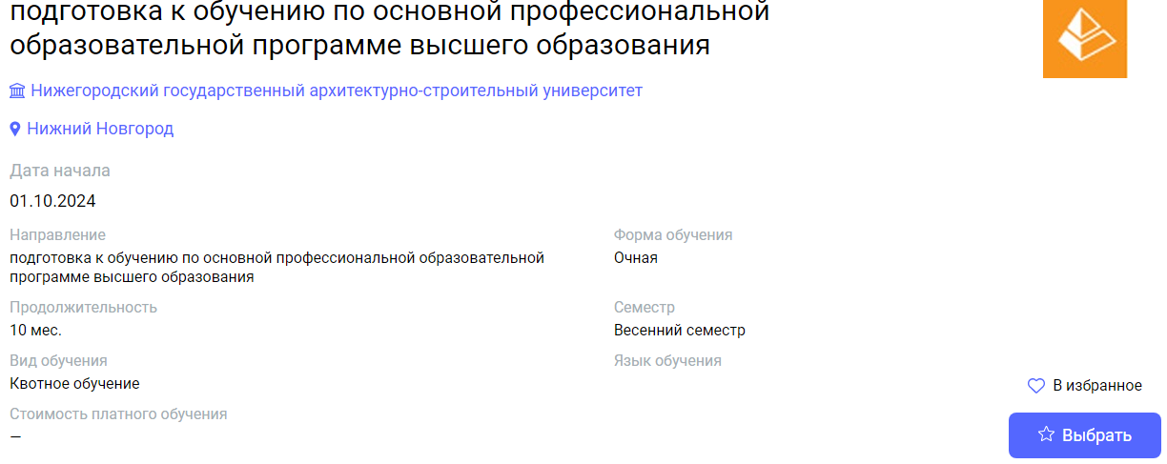
01.10.2024 | 10 | Nizhny Novgorod | Nizhny Novgorod State University of Architecture and Civil Engineering | Preparation for the main professional educational program of higher education 07.03.01 Architecture | Подготовка к обучению по основной профессиональной образовательной программе высшего образования 07.03.01 Архитектура | https://education-in-russia.com/education-in-russia/programs/123218  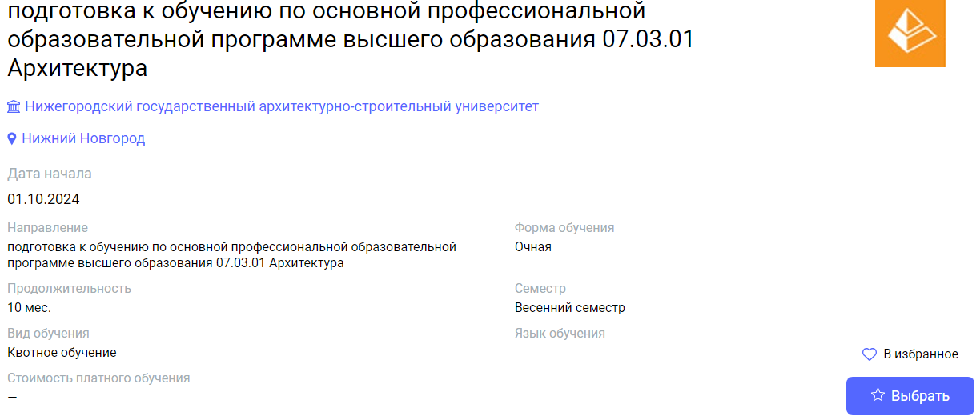
01.10.2024 | 10 | Nizhny Novgorod | Nizhny Novgorod State University of Architecture and Civil Engineering | Preparation for the main professional educational program of higher education 09.03.02 Information systems and technologies | Подготовка к обучению по основной профессиональной образовательной программе высшего образования 09.03.02 Информационнные системы и технологии | https://education-in-russia.com/education-in-russia/programs/123217  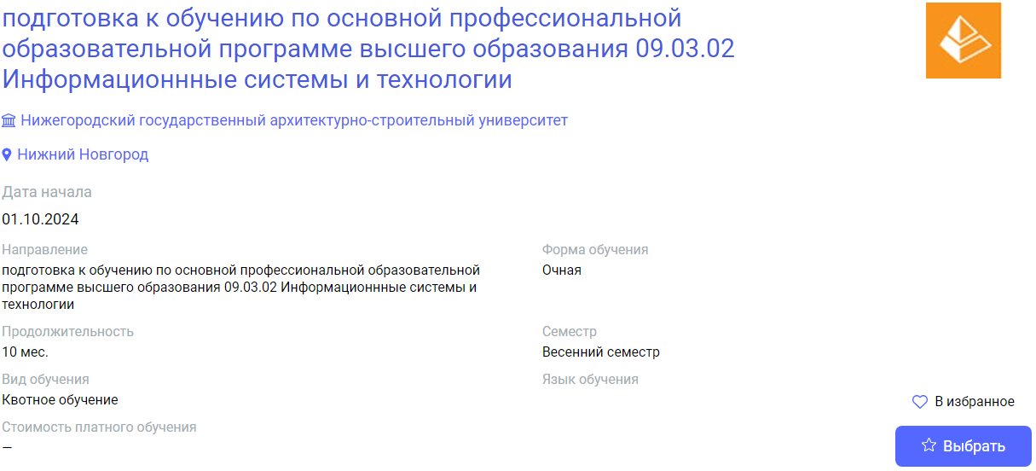
01.10.2024 | 10 | Nizhny Novgorod | Nizhny Novgorod State University of Architecture and Civil Engineering | Preparation for the main professional educational program of higher education 31.05.01 Medical Science | Подготовка к обучению по основной профессиональной образовательной программе высшего образования 31.05.01 Лечебное дело | https://education-in-russia.com/education-in-russia/programs/123216  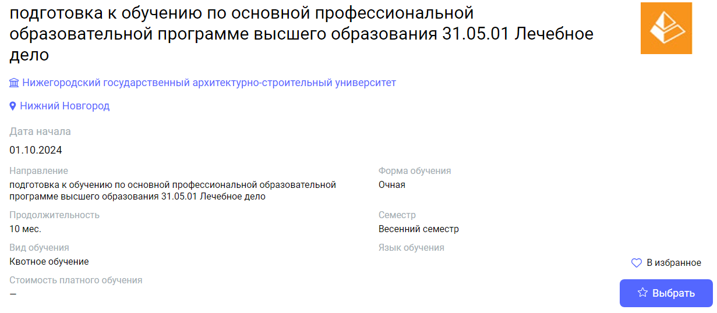
01.10.2024 | 10 | Novosibirsk | Novosibirsk National Research State University | Russian Language Courses | Русский как иностранный | https://education-in-russia.com/education-in-russia/programs/123604  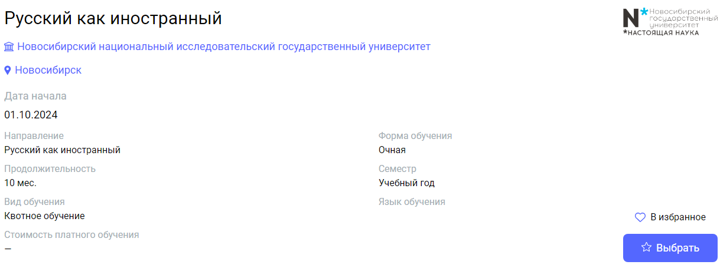
01.10.2024 | 1 | Birobidzhan | Sholom-Aleichem Priamursky State University | Teaching Russian as a foreign language in modern socio-cultural conditions | Обучение русскому языку как иностранному в современных социокультурных условиях | https://education-in-russia.com/education-in-russia/programs/123190  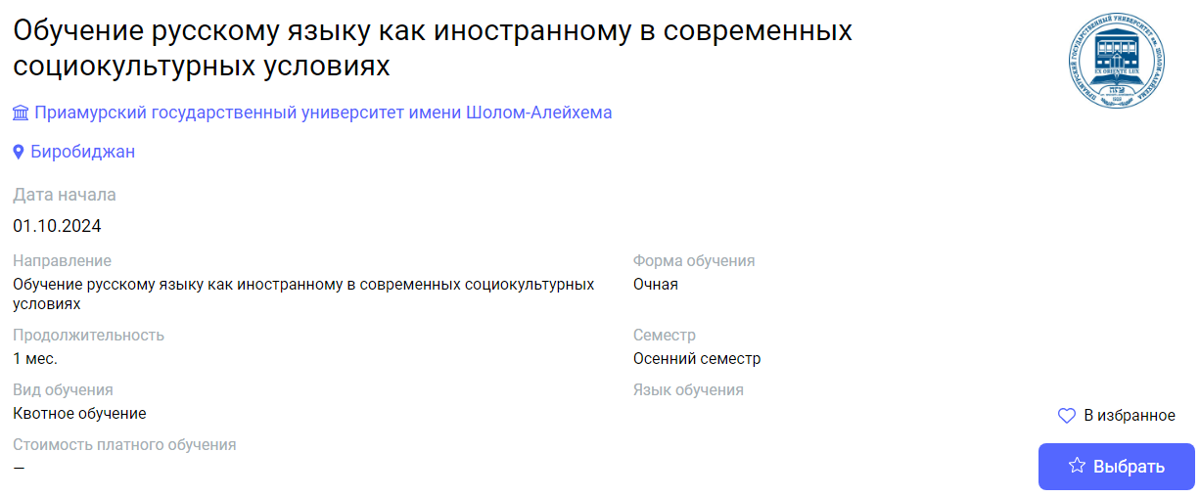
15.01.2025 | 5 | Vologda | Vologda State University | Russian as a Foreign Language, A2-B1 | Русский язык как иностранный, А2-B1 | https://education-in-russia.com/education-in-russia/programs/123145  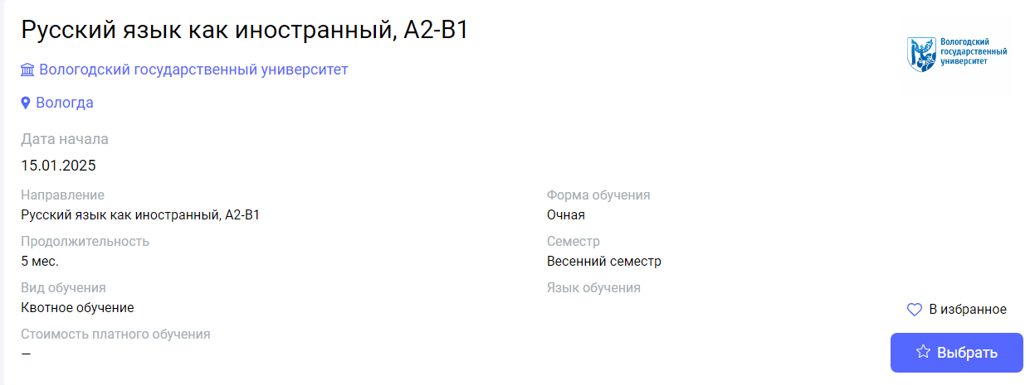
03.02.2025 | 5 | Irkutsk | Irkutsk State University | Russian as a foreign language | Русский язык как иностранный | https://education-in-russia.com/education-in-russia/programs/123642  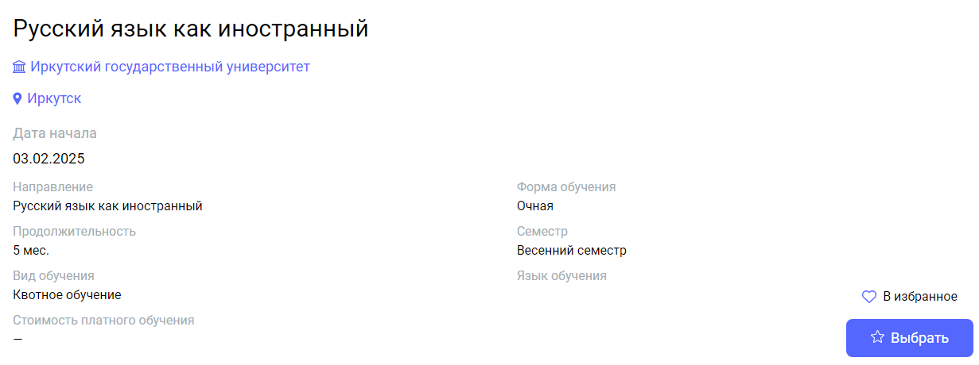
03.02.2025 | 4 | Birobidzhan | Sholom-Aleichem Priamursky State University | Russian language (within a particular field) | Русский язык (по отраслям) | https://education-in-russia.com/education-in-russia/programs/123189  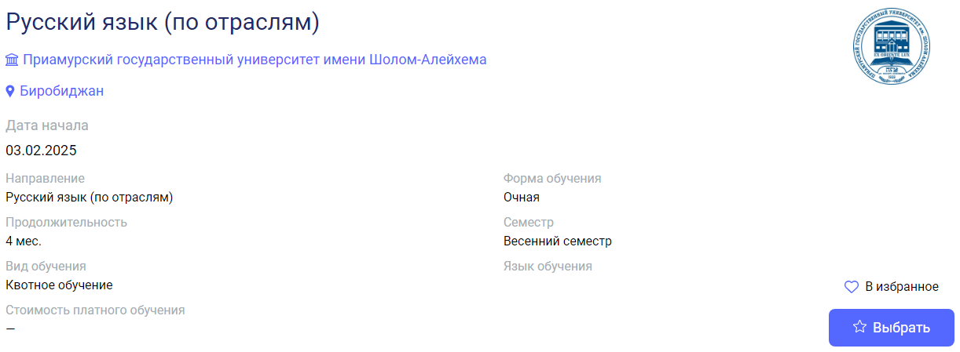
01.07.2025 | 1 | Nizhny Novgorod | Linguistics University of Nizhny Novgorod | Summer School "Nizhny Novgorod - Russia in a nutshell" (cultural and educational programme) (A1-A2) | Летняя школа: Дополнительная общеобразовательная программа "Нижний Новгород - Россия в миниатюре" (культурно-образовательная программа) (А1-А2) | https://education-in-russia.com/education-in-russia/programs/123513  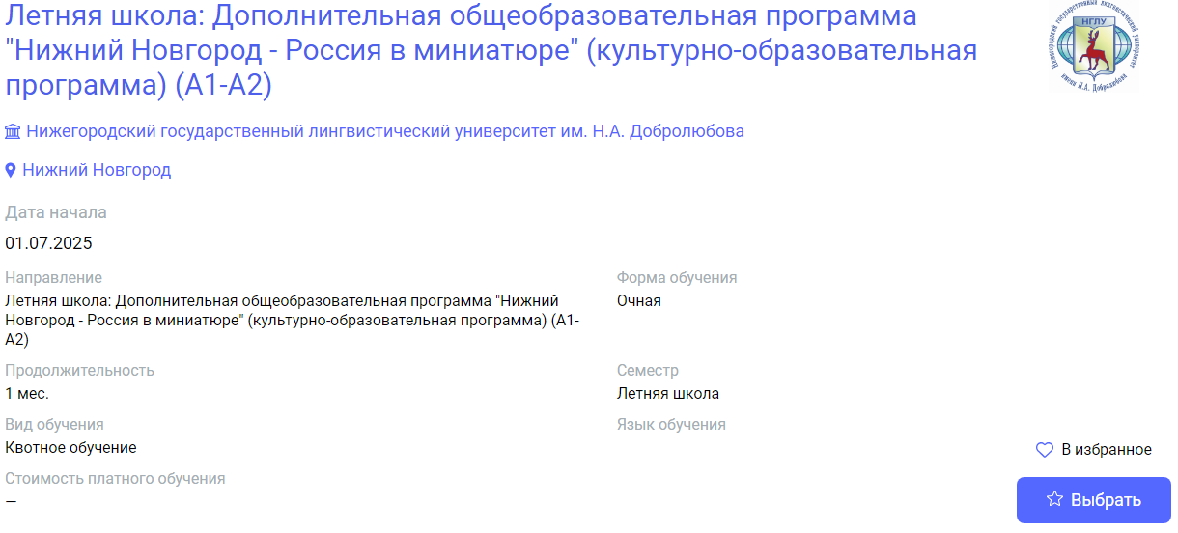
01.07.2025 | 1 | Nizhny Novgorod | Linguistics University of Nizhny Novgorod | Summer school "Russian as a Foreign Language" Introductory course (A1-A1+) | Летняя школа: Дополнительная общеобразовательная программа "Русский язык как иностранный: вводный курс (А1-А1+) | https://education-in-russia.com/education-in-russia/programs/123125  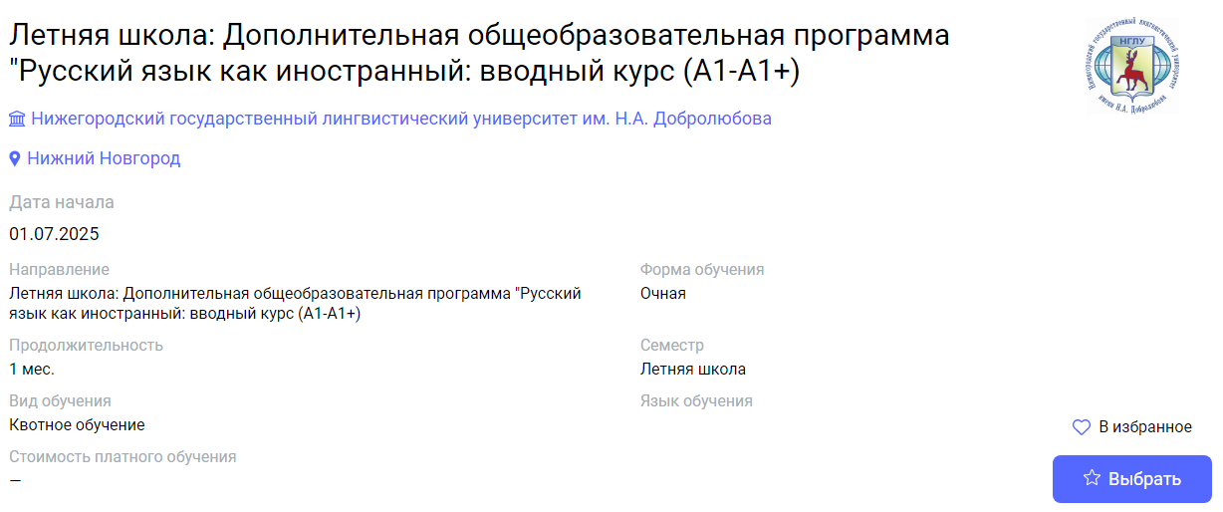
01.07.2025 | 2 | Nizhny Novgorod | Linguistics University of Nizhny Novgorod | Summer school "Russian as a Foreign Language" (from A1 to A2+) | Летняя школа: Дополнительная общеобразовательная программа "Русский язык как иностранный" (от А1 до А2+) | https://education-in-russia.com/education-in-russia/programs/123124  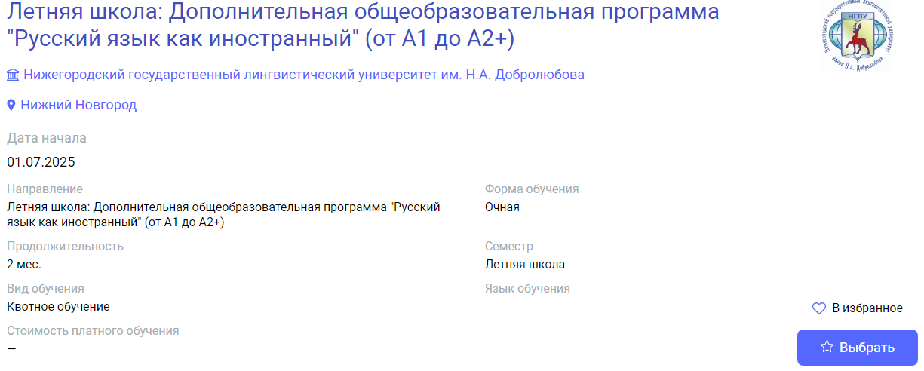
07.07.2025 | 0,5 | Tula | Tula State  Lev Tolstoy Pedagogical University | Russian Language on the Motherland of Leo Tolstoy | Русский язык на родине Л. Н. Толстого | https://education-in-russia.com/education-in-russia/programs/123650  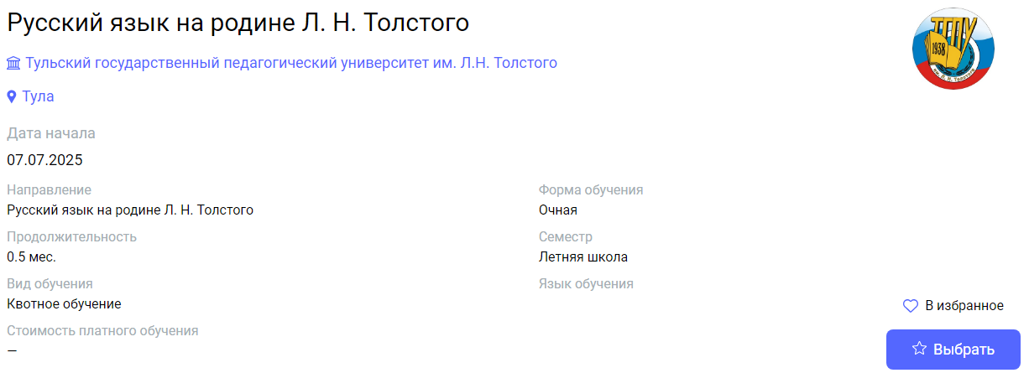
01.08.2025 | 1 | Nizhny Novgorod | Linguistics University of Nizhny Novgorod | Summer School "Nizhny Novgorod - Russia in a nutshell" (cultural and educational programme) (B1-B2) | Летняя школа: Дополнительная общеобразовательная программа "Нижний Новгород - Россия в миниатюре" (культурно-образовательная программа) (B1-B2) | https://education-in-russia.com/education-in-russia/programs/123515  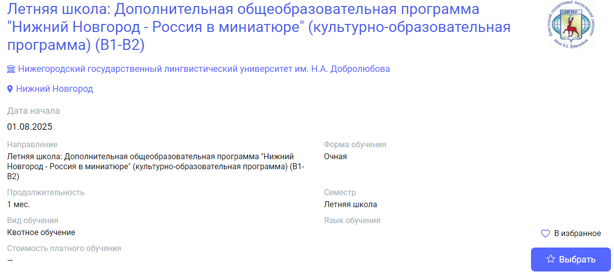
01.08.2025 | 1 | Nizhny Novgorod | Linguistics University of Nizhny Novgorod | Summer School "Russian as a Foreign Language" Basic Course" (A2) | Летняя школа: Дополнительная общеобразовательная программа "Русский язык как иностранный: базовый курс" (А2) | https://education-in-russia.com/education-in-russia/programs/123126  